Name_______________________________ Date___________
Period___________ Unit 8 Day 1 Homework

DIRECTIONS: Answer the questions under political cartoon. A colored version will be posted on the Fire Website and Google Classroom.

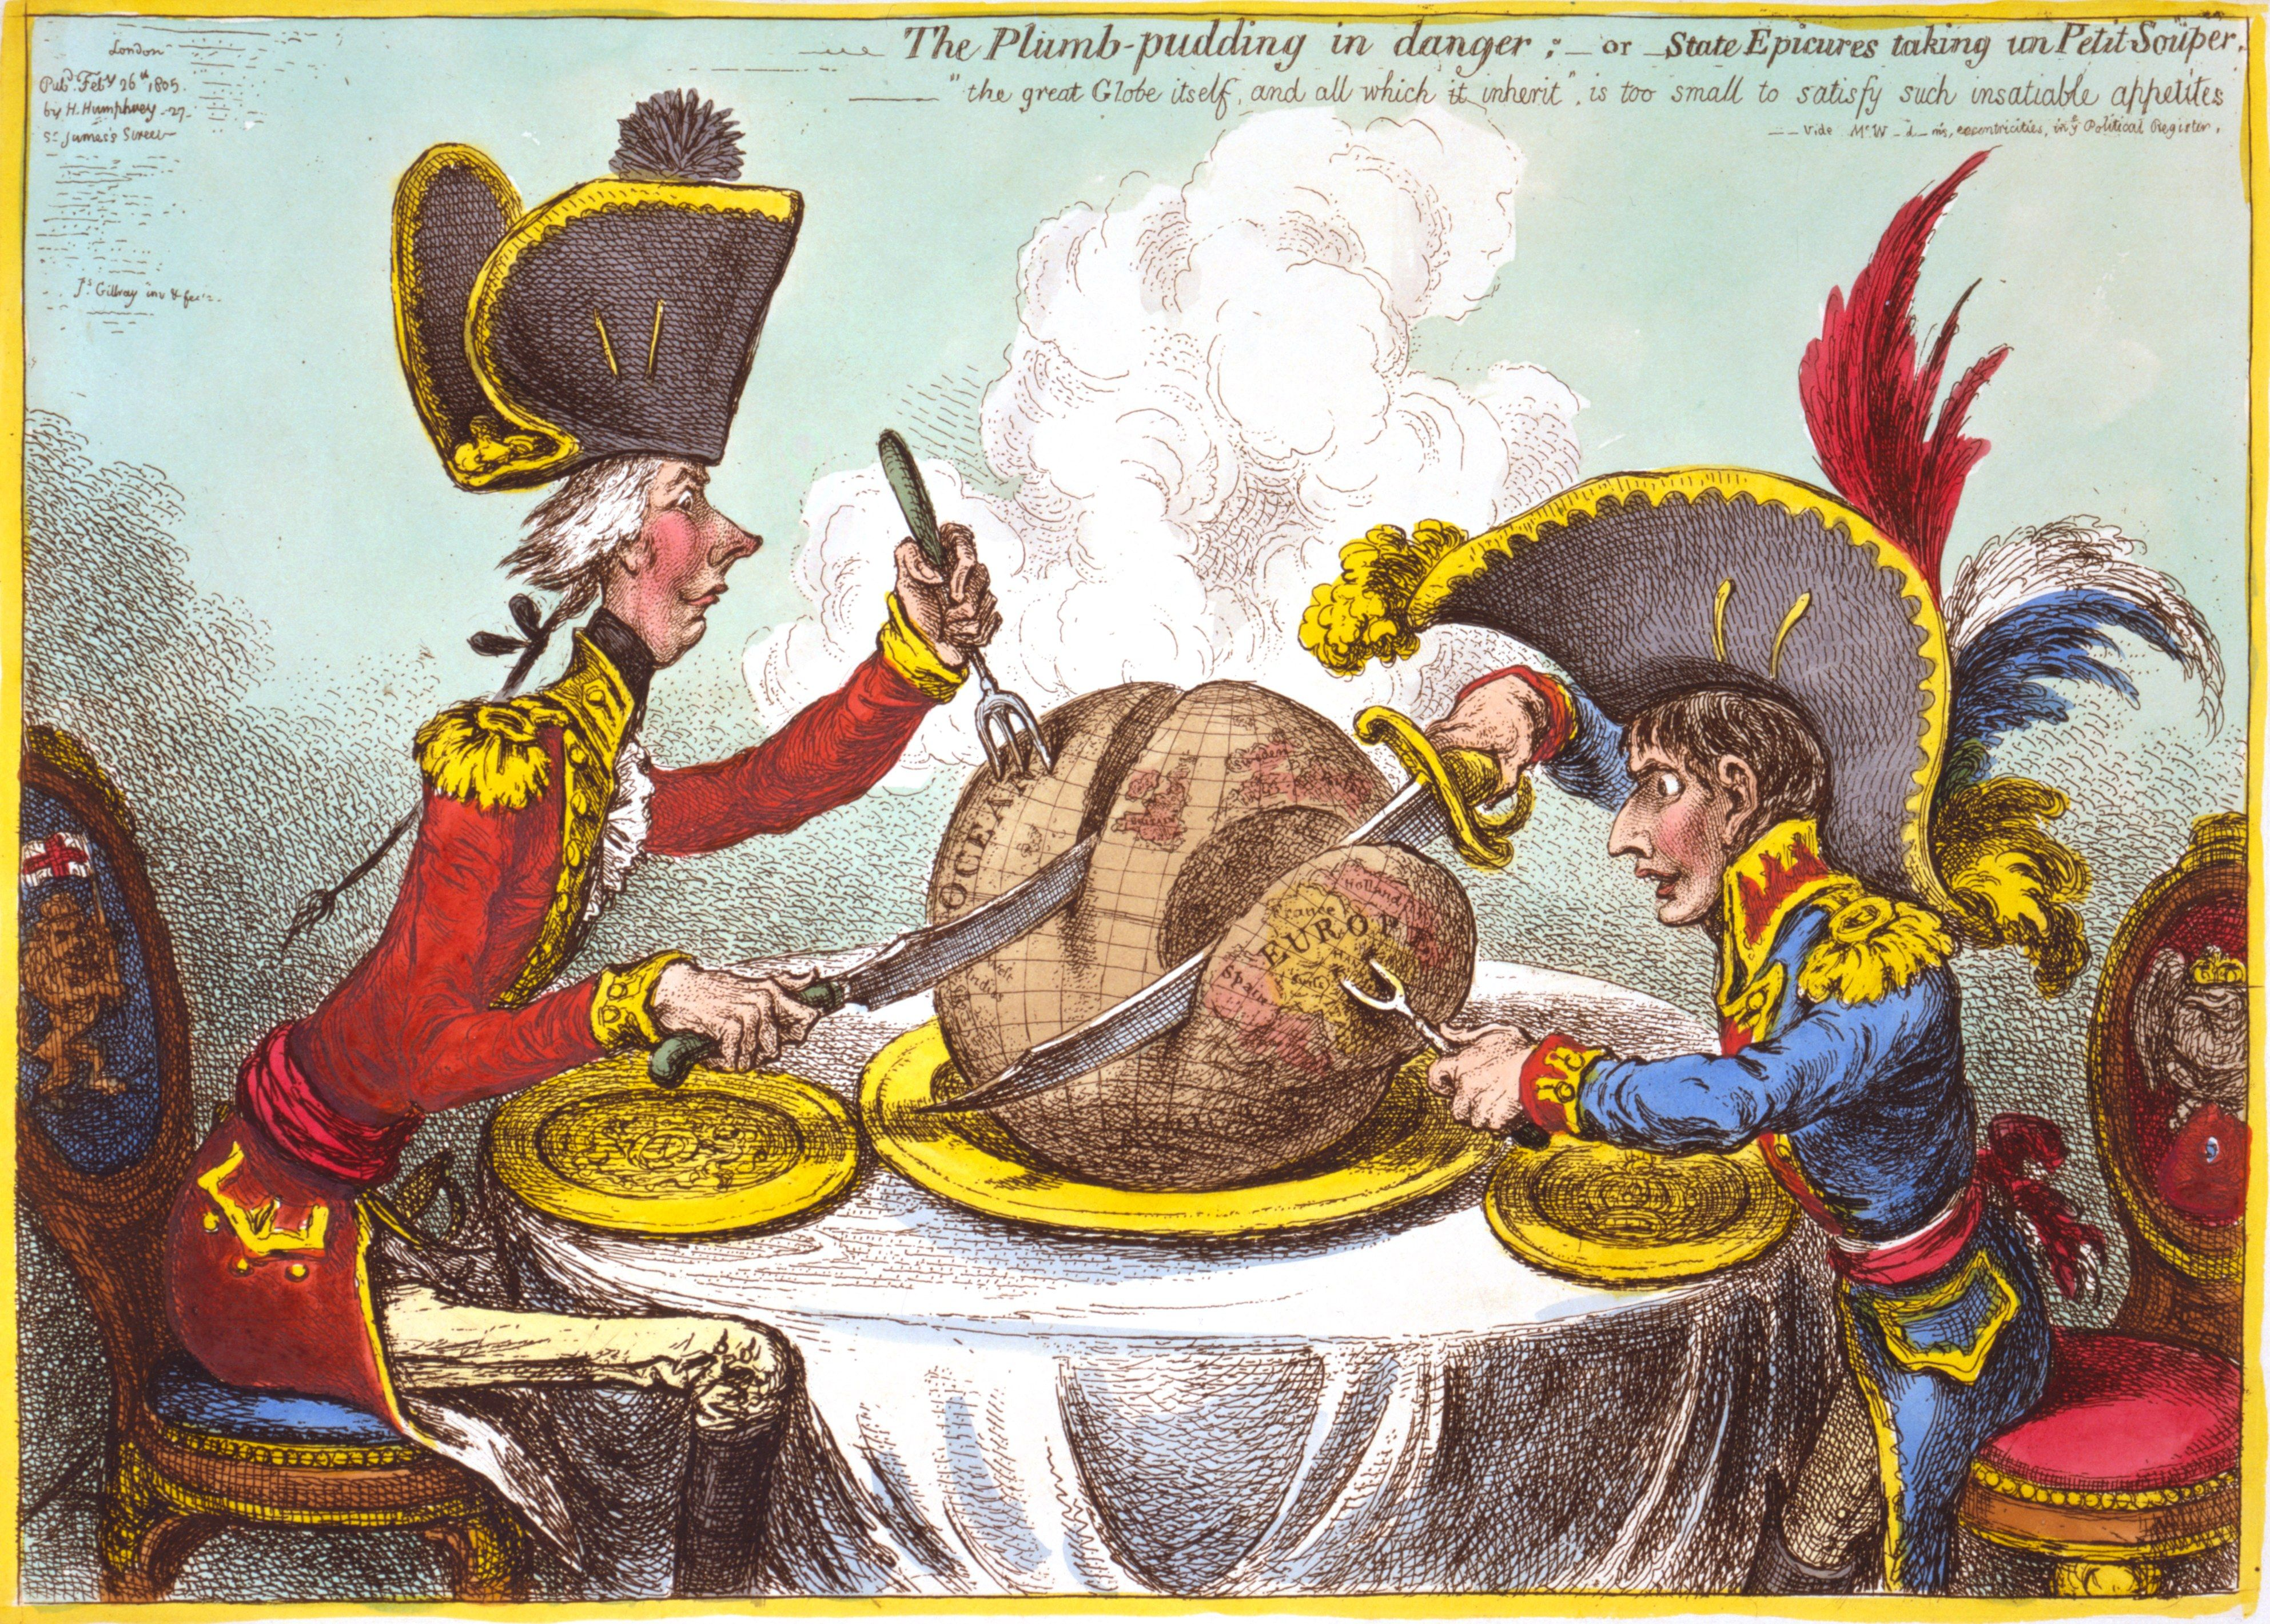
“The great Globe itself and all which it inherit” is too small to satisfy such insatiable appetites
King George III
Napoleon
Western Hemisphere
Europe

- Visual Clues
  - How can you tell the person on the left is King George III? (describe the visuals, not the words that say “King George III)
King George III is wearing a red coat, he was proper posture, un upturned nose, and white hair, the English flag is on his chair.
  - How can you tell the person on the right is Napoleon? (describe the visuals, not the words that say “King George III)
Napoleon is very short, he is taking the part of the world that is Europe, the feathers in his hat are the colors of the French flag.
Over

- Identify Main Ideas
  - What portion of the globe is Napoleon taking? Europe
  - What portion of the globe is King George taking? The Western Hemisphere
- Detect Points of View
  - What do you think the cartoonist’s opinion is of the two European leaders?
The cartoonist thinks they are greedy and power hungry as they are trying to eat the globe. The quote says they are “insatiable” so they won’t ever be full or happy with what they have.

