Name_____________________________________ Date__________________

Period________________ Unit 8 Day 1

Aim: How did Jefferson chart a new course for the government?

**Jefferson’s “Revolution of 1800”**

* Jefferson wanted to reduce government expenses to reduce federal power
  + Lowered military spending
  + Got rid of federal taxes
  + Cut the number of government employees
* Allowed the hated Alien and Sedition Acts to expire.
* Wanted to ease party disputes, or arguments
  + Pay off more state debts using federal money
  + Allow many federalists to keep their government jobs
  + Keep the Bank of the United States

**Strength of the Supreme Court – Marbury vs. Madison**

* Right before Jefferson took office, President Adams appointed Federalists to fill newly created federal judge positions.
  + One of these last-minute appointments was John Marshall as Chief Justice of the Supreme Court and William Marbury as a judge.
* Jefferson and other Republicans accuse Adams and the Federalists of trying to control the courts. Jefferson orders the Secretary of State, James Madison, not to deliver the official papers confirming Marbury’s appointment as judge.
* Marbury sues James Madison.
  + Judiciary Act of 1789 – stated that Congress gave the Supreme Court the power to give orders to the President and executive branch.
* Supreme Court rules against Marbury and declared the Judiciary Act unconstitutional.
  + The judicial branch could not order the executive branch to do something because it violated the Constitution and Separation of Powers.
* Judicial Review
  + 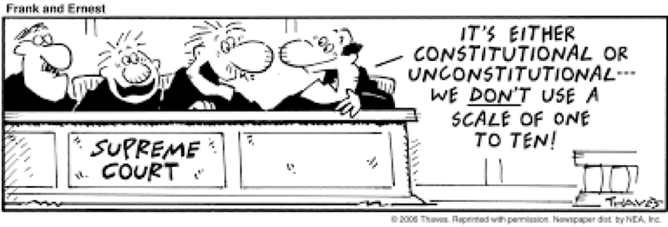The court case of Marbury vs. Madison set an important precedent. It gave the Supreme Court power to determine if local, state, and federal laws or government actions violate the Constitution. This is called Judicial Review.

**The Nation Looks West**

* Thousands of Americans had settled between the Appalachians and the Mississippi by the 1800s
* Settlers depended on the Mississippi and Ohio Rivers to move products east
* Jefferson worried about foreign control of New Orleans and Louisiana

|  |  |
| --- | --- |
| **Spanish Control** | **French Control** |
| * Spain controlled both New Orleans and Louisiana – land stretching from Miss. River to Rocky Mountains * Spain gave land to France in treaty | * French leader Napoleon wanted to rebuild France’s empire in North America * Rebellion in French colony of Haiti, in the Caribbean, ended Napoleon’s dream in 1802 |

**Purchasing the Louisiana Territory**

* Jefferson arranged the purchase of New Orleans and the rest of the Louisiana Territory in 1803
* France, who owned the Louisiana Territory, also controlled the Caribbean island of Haiti. Toussaint L’Ouverture led a revolt and nearly forced the French out of Haiti
* Napoleon (ruler of France) decided to sell the Louisiana Territory to the U.S. for $15 million
  + France needed money as a result of the problems in Haiti and wars they were fighting in Europe, so they sold the land cheaply
* Jefferson sends Livingston and Monroe to purchase the port of New Orleans (important for TRADE)

|  |  |
| --- | --- |
| Pros of Purchasing Louisiana Territory | Cons of Purchasing Louisiana Territory |
| * MCj04280650000[1]Increased the size of the US * Led to increase in population * Economic growth (more $) * Increased trade | * Need military presence in new territory * MCj04244680000[1]Land is currently occupied by Native Americans – creates many problems |

**Embargo Act**

* Trying to stay out of the conflicts between England and France, Jefferson pushes Congress to pass the Embargo Act, which forbids the Americans to export or import goods from any other country. (embargo = ban on foreign trade)
* The Embargo Act hurt Britain and France but hurt the U.S. economy even more.
  + Americans unable to get sugar, tea, molasses, etc.
  + Sailors out of work
  + Farmers could not sell and ship wheat, cotton, tobacco.
* Congress repealed (cancelled) the Embargo Act.