Name_________________________________ Date______________
Period____________ Unit 7 Day 3

Directions: Read the following 2 documents carefully. Then answer the three questions in blue or black ink. Please write clearly.

Document #1

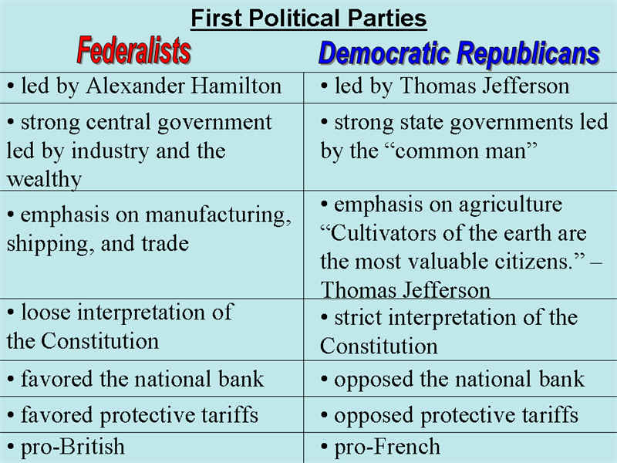

- According to the chart, who led the Federalist Party? Alexander Hamilton
- According to the chart, who led the Democratic Republican party? Thomas Jefferson
- Name and describe 1 issue that the political parties disagreed about.
Hamilton and Jefferson argued over the economy. Hamilton thought the economy should be built on trade and manufacturing and Jefferson thought the economy should be built on agriculture.
- How did the differences shown in the chart impact George Washington’s Cabinet?
The differences between Hamilton and Jefferson led to fighting in the Cabinet and led to Thomas Jefferson quitting as Secretary of the State. The differences in views led to the first political parties in the United States.

Document #2
Washington’s Farewell Address. September 17, 1796.
"However [political parties] may now and then answer popular ends, they are likely in the course of time and things, to become potent engines, by which cunning, ambitious, and unprincipled men will be enabled to subvert the power of the people and to usurp for themselves the reins of government, destroying afterwards the very engines which have lifted them to unjust dominion."

- Who is the author of the quote above? George Washington
- Why is the author making this address? Washington is leaving the office of the presidency and is warning the United States about possible problems in the future.
- What danger does the author warn the audience about? Political parties.
- Using details from the document, why did the author feel he needed to warn people of this danger? Washington felt that political parties would allow people to “subvert the power of the people and to usurp for themselves the reins of government.” This meant that ambitious people would want to control the government for themselves and take power away from the people.

