Name______________________________________ Date___________
Period______________ Unit 7 Day 2

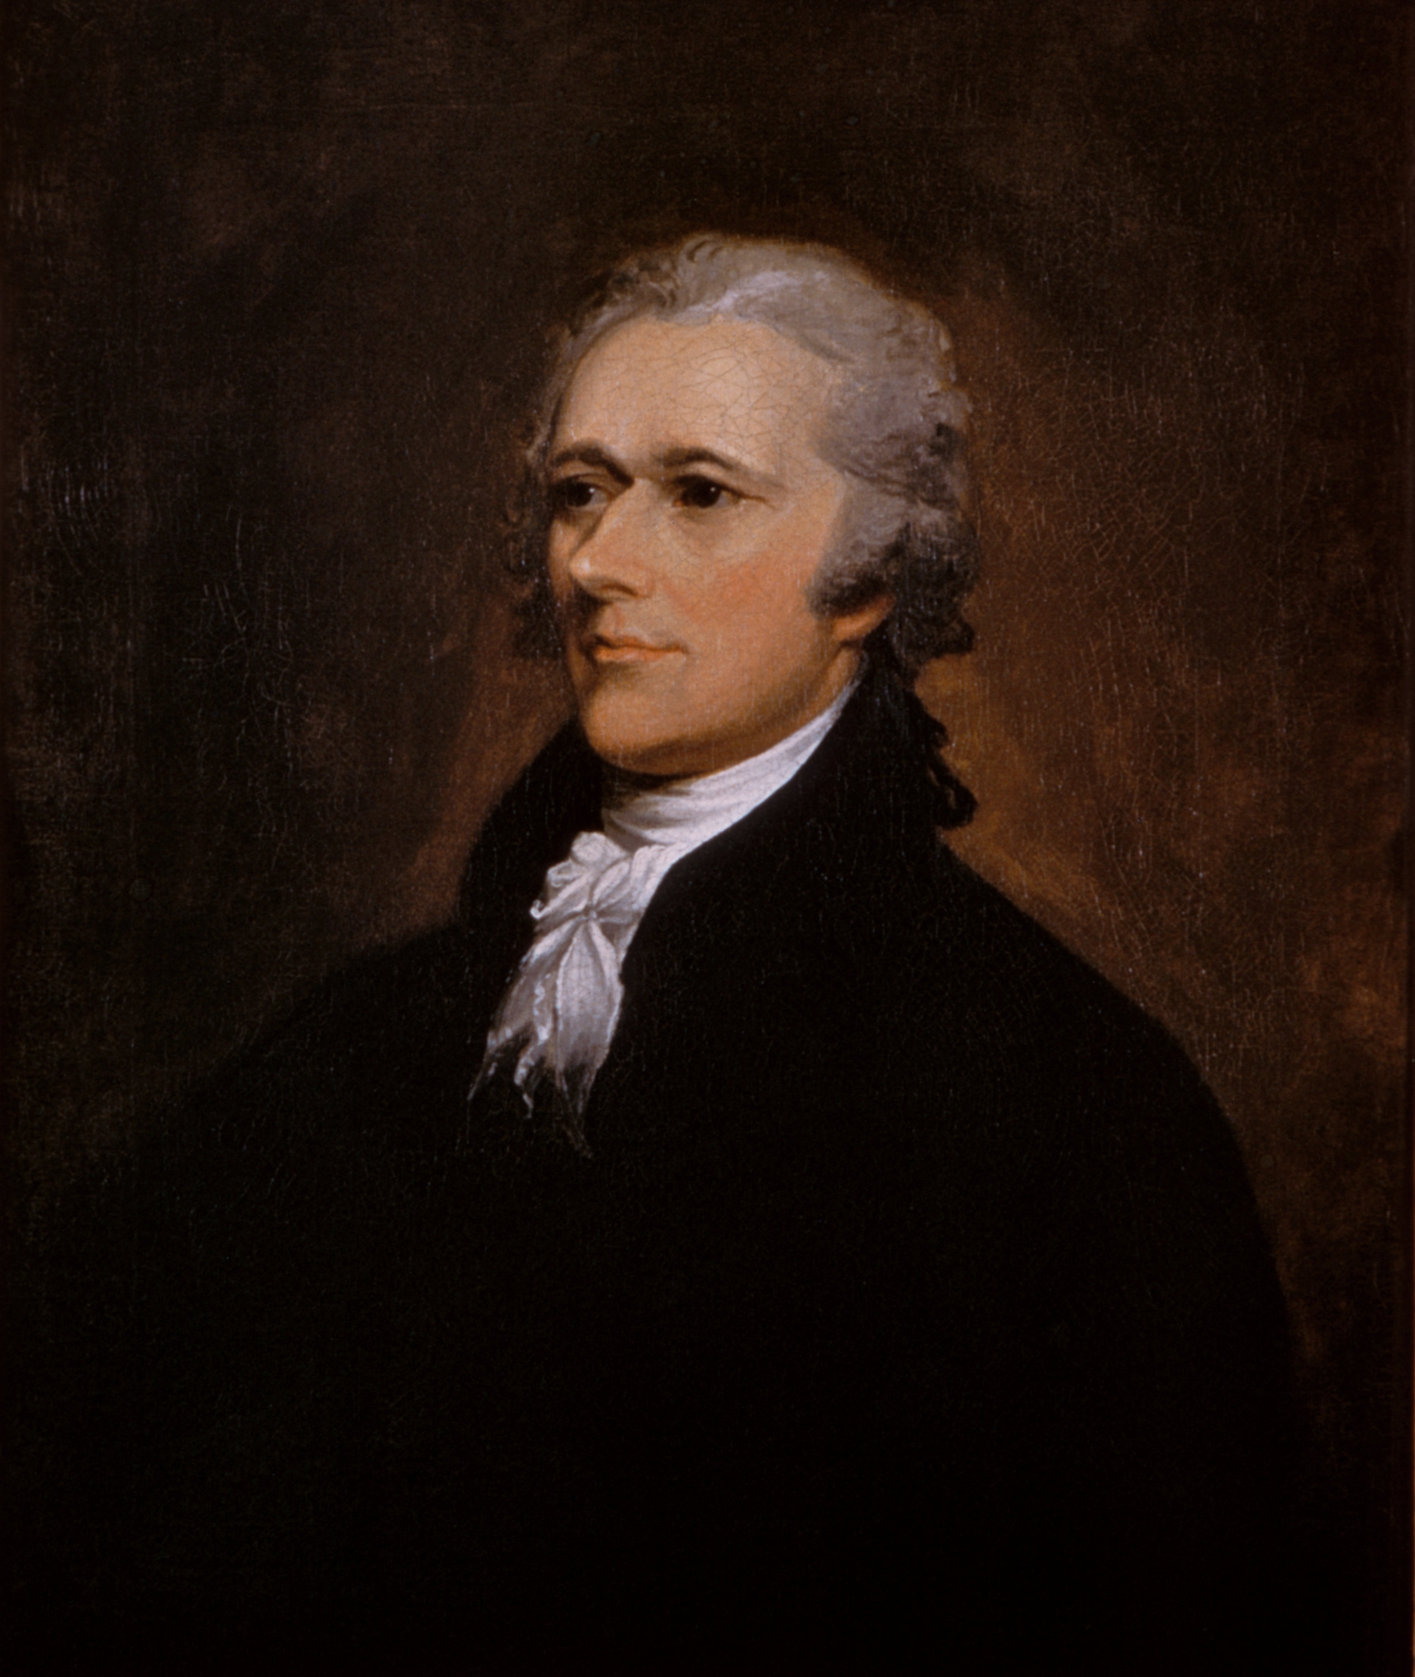
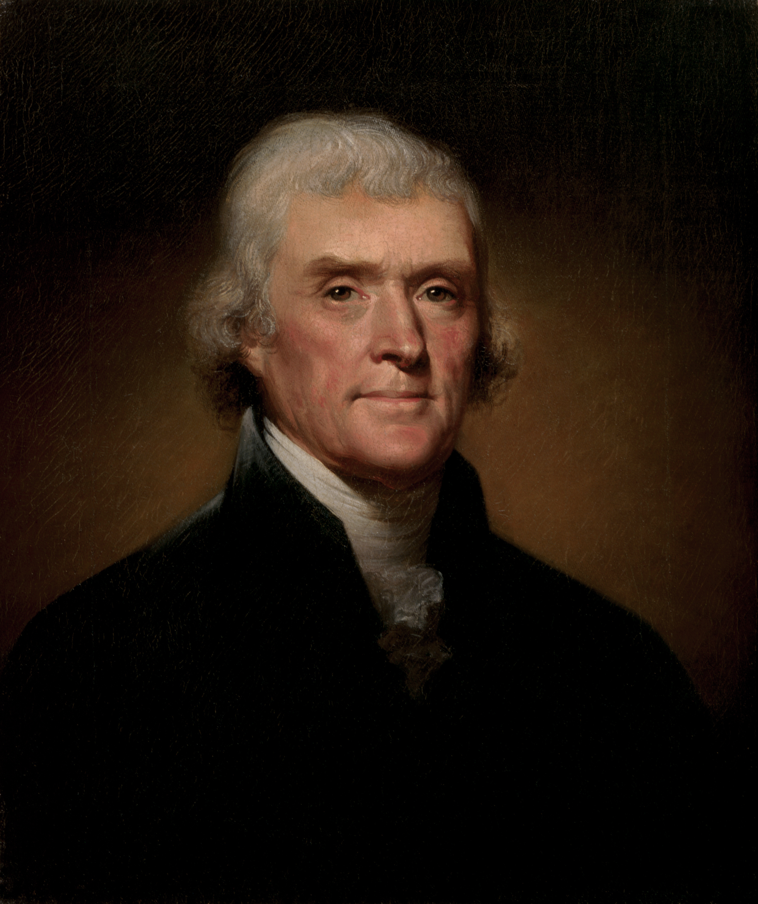
Hamilton V.

Jefferson
The 1st President - George Washington - 1789-1797
- George Washington was inaugurated (sworn in as president) in April, 1789.
- Washington soon named his cabinet. Members of the president’s cabinet act as the president’s advisors. Washington’s cabinet included:
  - Secretary of State – Thomas Jefferson
  - Secretary of the Treasury – Alexander Hamilton
  - Secretary of War – Henry Know
- Soon after Washington became president, Jefferson and Hamilton began to argue over the concerns of the nation. Their arguments soon led to the nation’s first political parties – the Federalists and the Democratic-Republicans.

 | Thomas Jefferson  (The Democratic-Republican Party) | Alexander Hamilton  (The Federalist Party)
Beliefs | - Believed that the "common" people were capable of running the government.  - Believed that vote qualifications should be opened so that more common people had the right to vote.  - Wanted to increase the rights of the states and was suspicious of the central Gov. because of England’s rule over the colonies.  - Wanted an alliance with the French | - Believed that mostly the wealthy should run society (not the common people).  - Believed that vote qualifications be very strict.  - Believed in a strong central or federal government.  - Wanted an alliance with the British
Economy /National Bank | - Opposed the National Bank because he believed that it was unconstitutional - instead, he wanted to encourage the development of state banks.  - Preferred an economy based on agriculture (individual farmers). | - Wanted to create a National Bank to provide loans for businessmen, and to provide a place to deposit federal funds.  - Preferred an economy based on business (entrepreneurship, businessmen, finance).
The Constitution  Directions: Who said it - Hamilton or Jefferson?  - Read the quote and Identify the author (Hamilton or Jefferson)  - Highlight the information in the chart above that helped you identify the author. | - Were called “strict constructionists” because they argued that the national Gov. could only have the powers specifically listed in the Constitution. | - Were called “loose constructionists” because they argued that the Constitution allowed the federal government to do whatever was “necessary and proper.”

QUOTE 2: ““Our governments will remain virtuous (pure) for many centuries; as long as they are chiefly agricultural.” (1787)

Thomas Jefferson
QUOTE 1: “I believe the British government forms the best model the world ever produced, and such has been its progress in the minds of many that this truth gradually gains ground.” (1787)

Alexander Hamilton

Historical Background - The French Revolution
The French Revolution started in 1789, when French citizens stormed the Bastille Prison, and tore it down. The French government had helped the United States win the Revolutionary War. Now, Washington had to decide whether the U. S. should help France in their war. Jefferson and Hamilton were on opposite sides of the issue.

[WASHINGTON]  The issue on the table: France is on the verge of war with England, and do we provide aid and our troops to our French allies or do we stay out of it? Remember, my decision on this matter is not subject to congressional approval. The only person you have to convince is me. Secretary Jefferson, you have the floor, sir  [JEFFERSON]  When we were on death’s door, when we were needy  We made a promise, we signed a treaty  We needed money and guns and half a chance  Who provided those funds?  [MADISON] France  [JEFFERSON]  In return, they didn’t ask for land  Only a promise that we’d lend a hand  And stand with them if they fought against oppressors  And revolution is messy but now is the time to stand  Stand with our brothers as they fight against tyranny  I know that Alexander Hamilton is here and he  Would rather not have this debate  I’ll remind you that he is not Secretary of State  He knows nothing of loyalty  Smells like new money, dresses like fake royalty  Desperate to rise above his station  Everything he does betrays the ideals of our nation  [ENSEMBLE] Ooh!!  [JEFFERSON]  Hey, and if ya don’t know, now ya know, Mr. President  [WASHINGTON]  Thank you, Secretary Jefferson. Secretary Hamilton, your response  [HAMILTON]  You must be out of your mind if you think  The President is gonna bring the nation to the brink  Of meddling in the middle of a military mess  A game of chess, where France is Queen and Kingless  We signed a treaty with a King whose head is now in a basket  Would you like to take it out and ask it?  “Should we honor our treaty, King Louis’ head?”  “Uh… do whatever you want, I’m super dead.” | 1. What is Washington asking Jefferson and Hamilton to discuss?  To help decide if the United States should help France fight England by giving money/aid to France.  2. What is Jefferson arguing here? Why? Explain his reasoning.  The US signed a treaty promising to help France if they were involved in a war/conflict. The French helped the US fight the British so the US should help them in return.  tyranny - definition – complete control of a government/abusing citizens
[WASHINGTON] Enough. Hamilton is right  [JEFFERSON] Mr. President—  [WASHINGTON] We’re too fragile to start another fight  [JEFFERSON] But sir, do we not fight for freedom?  [WASHINGTON] Sure, when the French figure out who’s gonna lead ‘em  [JEFFERSON] The people are leading—  [WASHINGTON]  The people are rioting  There’s a difference. Frankly, it’s a little disquieting you would let your ideals blind you to reality  Hamilton  [HAMILTON] Sir  [WASHINGTON] Draft a statement of neutrality  [JEFFERSON] Did you forget Lafayette?  [HAMILTON] What?  [JEFFERSON]  Have you an ounce of regret?  You accumulate debt, you accumulate power  Yet in their hour of need, you forget  [HAMILTON]  Lafayette’s a smart man, he’ll be fine  And before he was your friend, he was mine  If we try to fight in every revolution in the world, we never stop  Where do we draw the line?  [JEFFERSON] So quick-witted  [HAMILTON] Alas, I admit it  [JEFFERSON] I bet you were quite a lawyer  [HAMILTON] My defendants got acquitted  [JEFFERSON] Yeah. Well, someone oughta remind you  [HAMILTON] What?  [JEFFERSON] You’re nothing without Washington behind you  [WASHINGTON] Hamilton!  [JEFFERSON] Daddy’s calling! | 3. What is Hamilton arguing here? Why? Explain his reasoning.  Helping the French could bring the US into a military mess. The US signed a treaty with the King of France, not the people of France, and the people killed the king. The US doesn’t owe their allegiance to the people.  Washington’s Neutrality Proclamation (define)  The US would remain natural and not choose sides between France and England as they fight each other.
1. Who’s going to speak first? _________________
2. What are they going to argue? What point-of-view are they going to make with their statement? (Maybe throw in an insult? Maybe they brag?)
Introduction (spoken by George Washington): Announce the rap battle. What issue would you like your rappers to discuss?
In this outline, you will be discussing the ideas you have for your rappers to debate. As this is just an outline, you do not need your ideas to rhyme - you will develop your rhymes for the final version of your rap.
Outline for your Rap Battle

________________________________________________________________________________________________________________________________________________________________________________________________________________________________________________________________________________________________________

Part 1:

____________________________________________________________________________________________________________________________________________________________________________________________________________________________________________________________________________________________________________

1. Who’s going to speak second? _________________
2. What are they going to argue? What point-of-view are they going to make with their statement? (Maybe throw in an insult? Maybe they brag?)
Part 2:

________________________________________________________________________________________________________________________________________________________________________________________________________________________________________________________________________________________________________

