Name__________________________________ Date__________

Period_______________ Unit 6 Day 8

**The Bill of Rights**

As a result of their experiences as British subjects, many Americans during and immediately after the Revolution feared that a political system with a strong central government would threaten their individual rights. As colonists, the Founders had been badly treated by the British. Not surprisingly, the Founders wanted to place clear limits on government power. The U.S. Constitution was proposed in 1787. It spelled out the offices and powers of the new government. However, it did not lay out the powers or rights of the people.

At first, the Constitution had no **bill of rights**. Many of the people at the Constitutional Convention did not think it was needed. They believed that the government had only the powers it was given. If a power was not listed as belonging to the government, it was not a power of the government. According to this reasoning, there was no need for a bill of rights because the Constitution did not give government the power to attack people’s rights.

Many people did not like the Constitution. Some of these people were Anti-Federalists such as George Mason. They worried that the central government would be too powerful. They also worried that it would threaten people’s rights. Anti-Federalists wanted to be sure that their rights would be protected. Thomas Jefferson was not an Anti-Federalist, but he believed the people should have a list of rights. Many state constitutions already included bills of rights limiting the power of state governments.

James Madison wrote the suggested amendments to identify particular rights of the people against the government. To amend something means to “change and improve it.” In several states, the amendments helped convince state lawmaking groups to accept the Constitution. By 1791, the states agreed on 10 amendments known as the Bill of Rights.

In the years since the Bill of Rights was ratified, or approved, 17 more amendments have been added to the Constitution. Nine of these also protect an individual person’s rights.

1. What does the word “amend” mean? ***to change and improve.***
2. Which group wanted a bill or rights to be included in the Constitution? ***Anti-Federalists***
3. What does the word “ratify” mean? ***to approve***

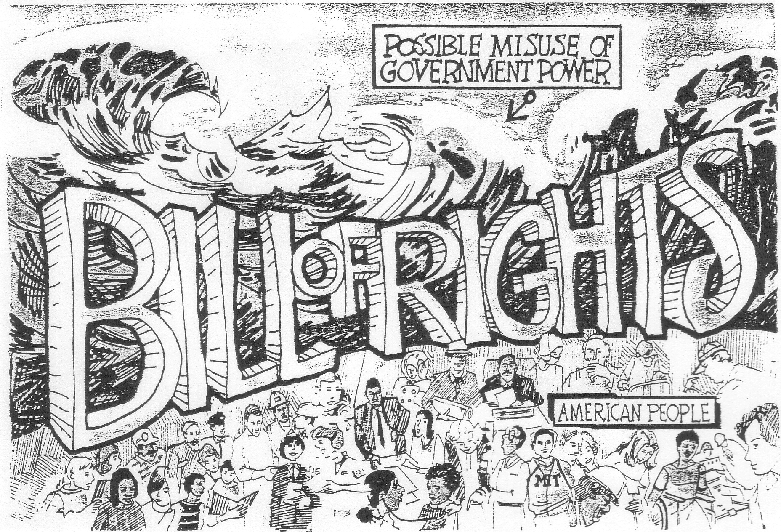

1. In the cartoon, what protects the American people from any possible evils of government?

***The Bill of Rights***

1. Does the cartoonist think that the Bill of Rights is strong enough to do the job?

***Yes- the Bill of Rights is protecting the American people from possible misuse of government power.***

1. Write what you think would be a good title or caption for this cartoon?

***Answers will vary.***

1. In the space provided write down as many rights or freedoms that you think are or should be protected by the Bill of Rights.

***Answers will vary.***

**The Bill of Rights: The First 10 Amendments**

|  |
| --- |
| **1st Amendment**   * Guarantees freedoms of religion, speech and the press, and rights of assembly and petition. |
| **2nd Amendment**   * Guarantees the right to keep and bear arms. |
| **3rd Amendment**   * Prohibits the quartering of soldiers in one’s home. |
| **4th Amendment**   * Prohibits “unreasonable” searches and seizures. |
| **5th Amendment**   * No citizen may be deprived of life, liberty or property without due process of law (legal procedures carried out according to established rules, such as a fair trial) * Requires grand jury indictments (formal charge for committing a serious crime) * Prohibits double jeopardy (being tried twice for the same crime) * Prohibits self incrimination (individuals may not be forced to give evidence against themselves) |
| **6th Amendment**   * Guarantees that those accused of a crime have the right to:   + a speedy trial by jury   + confront accusers   + be represented by a lawyer |
| **7th Amendment**   * Guarantees a jury trial in many civil cases. |
| **8th Amendment**   * Prohibits excessive bail and cruel and unusual punishment. |
| **9th Amendment**   * The listing of some Constitutional rights does not mean that people do not enjoy other rights. |
| **10th Amendment**   * Reserves to the states and the people all rights not delegated to the federal government. |

**“Other Amendments”**

|  |
| --- |
| **11th Amendment (1795)**   * Lawsuits against the states. |
| **12th Amendment (1804)**   * Separate voting for President and Vice President. |
| **13th Amendment (1865)**   * Abolition of slavery. |
| **14th Amendment (1868)**   * Citizenship and civil rights. |
| **15th Amendment (1870)**   * Voting rights for African American men. |
| **16th Amendment (1913)**   * Income tax. |
| **17th Amendment (1913)**   * Direct election of senators. |
| **18th Amendment (1919)**   * Prohibition of alcoholic beverages. |
| **19th Amendment (1920)**   * Voting rights for women. |
| **20th Amendment (1933)**   * Terms of the President, Vice President and Congress. |
| **21st Amendment (1933)**   * Repeal of the 18th Amendment. |
| **22nd Amendment (1951)**   * President limited to two terms. |
| **23rd Amendment (1961)**   * Electoral votes for the District of Columbia. |
| **24th Amendment (1964)**   * Abolition of poll taxes. |
| **25th Amendment (1967)**   * Presidential disability and succession. |
| **26th Amendment (1971)**   * Voting age lowered to eighteen. |
| **27th Amendment (1992)**   * Changing congressional salaries. |

**Can You Do This?**

The farmers of the Constitution did not think it was necessary to list the individual rights of the people when they wrote the document in 1787. Several states, however, refused to ratify the new plan of government until a Bill of Rights was added. This was done in 1791, and the first ten amendments became a part of the Constitution.

The First Amendment guarantees the freedoms of religion, speech and the press, assembly and petition. People may practice the religion of their choice. They may say or print whatever they wish, as long as it is true. People may meet peacefully and discuss issues without fear of reprisal (the use of force). Finally, they can petition or complain to the government about things they do not like.

Each freedom listed in the First Amendment, however, has limitations. Although people are allowed to express their opinions, for example, they are not allowed to say or print things that would harm someone’s reputation. Obscenities are not permitted in public. Any speech that endangers lives or property is also prohibited.

To the left of each of the statements below, write ***Yes*** if it is something a citizen is permitted to do or ***No*** if it is an act that is not allowed.

|  |  |  |
| --- | --- | --- |
| 1. | ***YES*** | Give a speech before a large gathering of people and express opinions about the president’s abilities. |
| 2. | ***NO*** | Write a letter to the White House threatening to harm the president. |
| 3. | ***NO*** | Yell “fire” in a movie theater when there is no fire. |
| 4. | ***YES*** | Write a letter for the editorial page of a newspaper in which you criticize a state legislator. |
| 5. | ***NO*** | Make up a story about a teacher that causes him or her to be reprimanded or even fired. |
| 6. | ***NO*** | Participate in a street demonstration that causes traffic problems. |
| 7. | ***YES*** | Circulate a petition calling for the repeal of an unpopular law. |
| 8. | ***YES*** | Give an opinion on an issue being discussed at a local school board meeting. |
| 9. | ***NO*** | Use profanity [cursing] in public. |
| 10. | ***NO*** | Require employees to attend religious services. |

**The Amendment Process**

|  |  |
| --- | --- |
| 1. AMENDMENT IS PROPOSED BY:  MCj01884850000[1]  (2/3 vote of both houses of Congress) | |
| 2. AMENDMENT IS APPROVED BY:  MCj04084370000[1]  ¾ of the state legislatures  (37 states) | 3. BECOMES PART OF:  MCj01495110000[1]  The United States Constitution |

What conclusion about the Amendment Process can be drawn from the diagram?

***The elected officials in Congress (federal government) and the elected officials in the state legislatures (state government) work together to decide if Amendments, changes, should be added to the Constitution.***