Name______________________________________ Date___________
Period______________ Unit 6 Day 7

Federalism and Separation of Powers
The United States Constitution creates a central government known as the federal government. The federal government deals with issues that affect the entire country. Each state also has its own state government that only handles the affairs of the state. This division of power between a central (national) government and state governments is called federalism.
The federal government gets all of its power from the Constitution. In order to keep the federal government from becoming too powerful, the Constitution says that any power not given to the federal government is a power the states or the people keep for themselves. These powers are said to be reserved to the states. There’re also a few powers that both the states and the federal government share! These are called concurrent powers because concurrent means happening at the same time.
Another problem facing the Constitutional Convention was how to divide the powers of government. Who will make the laws? Who will make sure the laws are obeyed? Who will make sure the laws are “good” laws? These questions are answered in the next set of compromises.
American government can be seen as a tree. The Constitution is the trunk, or base, with three branches extending from that trunk. Those branches are the legislative branch, the executive branch, and the judicial branch. Each branch has different jobs and responsibilities. This concept is called separation of powers.
The legislative branch was defined during the Great Compromise. Together, the House of Representatives and the Senate make the laws to govern our country.
The second branch is the executive branch. Eventually, the delegates decided to create a chief executive, or a president. Under the Articles of Confederation, there was no president. The founding fathers had feared creating another “king.” There was much discussion, even talk of having two equally powerful leaders. The convention agreed to create one President. The job of the President and the executive branch is to carry out the laws passed by the legislative branch.
The third branch is the judicial branch. The judicial branch was to be headed by the Supreme Court. It is the job of the Supreme Court to interpret or define the laws. The Supreme Court is chosen by the President and approved by the Senate..
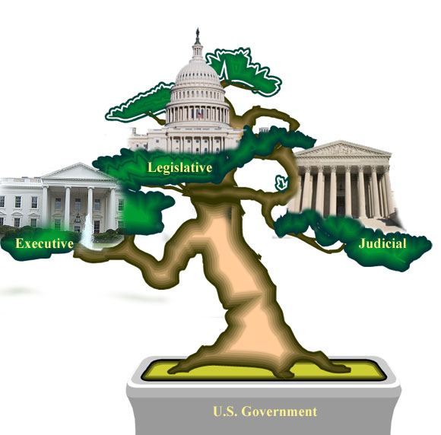
Each branch has its own specific responsibilities. Each has a separate power. Part of the responsibility of a branch is to control or check the power of the other branches. That way, no one branch gets to be too powerful; each branch is balanced.

Directions: Using the reading, answer the following questions.

- Define:
  - Federalism: division of power between a central (national) government and state governments
  - Reserved Powers: any power not given to the federal government is a power the states or the people keep for themselves
  - Concurrent Powers: few powers that both the states and the federal government share
  - Separation of Powers: division of power between the three branches of government
- Why are the powers of the three branches of government separated?
So that one branch does not become more powerful than another.
- What is the job of the legislative branch?
The job of the legislative branch is to make the laws that govern our country.
- What is the job of the executive branch?
The job of the executive branch is to enforce and carry out the laws.
- What is the job of the judicial branch?
The job of the judicial branch is to interpret or define the laws.

