Name _________________________________________ Date __________
Period ______ Unit 6, Day 2

**Laws that were created as part of the Articles of Confederation:
Law #1: Land Ordinance of 1785
What was the problem with the “western lands”?
The western lands were claimed by many states. Their claims often overlapped, and some states were left out entirely.
Where were the western lands? Color this area with your highlighter!
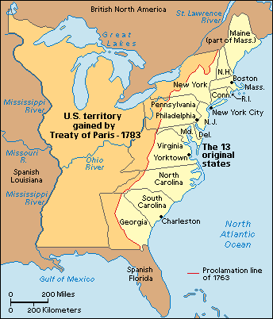

Two reasons why the newly formed United States wanted to settle the western lands were:
- To encourage people to move to the area, and:
- To raise money for the government
The government owned land was first divided up into townships, which were 6 miles by 6 miles (a total of 36 square miles). Then, the land was further divided into sections, which were 1 mile by 1 mile, for a total of 640 acres. These sections could be sold for $1 per acre.
People who bought the land with the plan to sell it were called land speculators, and these people made a lot of profit through land sales.
**Draw a picture in the box to represent the Land Ordinance of 1785:

Law #2: Northwest Ordinance
Set up rules for how the western lands could become new states.
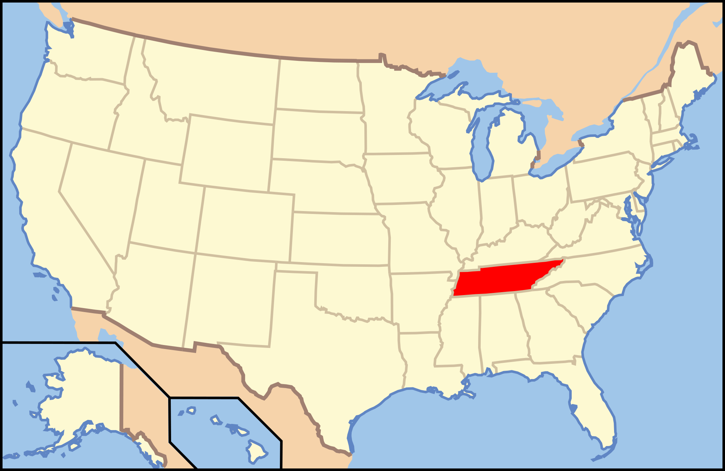
Once the population in an area had:

5,000 free men

Then, the people could:

Set up a government

Then, the area could apply to become a new state when:

The population reached 60,000 people

Shays’ Rebellion
Why were farmers in debt, and losing their homes?
The farmers were previously soldiers in the Revolutionary War, and weren’t paid. As a result of their debts, the banks were seizing their farms and homes.
Who was Daniel Shays? He was a former soldier in the Revolutionary War who organized an armed protest.
What did Daniel Shays do? He and his followers stormed courthouses in Massachusetts and wouldn’t let the judges into the buildings. They tried to take over the federal arsenal. Four men were killed and many wounded.
Shays’ Rebellion proved that the Articles of Confederation were not working and had to be revised.
Draw a picture to represent Shays’ Rebellion

