Name_______________________________ Date________
Period___________ Unit 6 Day 1

Aim: How did the Articles of Confederation show the different views of government in the newly independence United States of America?

Governing the New Nation
- After the war, the United States needed to form a national government that governed ALL states.
- Each state had their own form of government that was different than the others.
  - They were not united under one central government.
- The Continental Congress was formed to help create a new constitution.
  - A constitution was a written document that organizes and explains the rules and roles of the government.
Fears of a Strong National Government
- The States were afraid that:
  - Another king would rule them.
  - The people would have no power in government.
  - Some states would be more powerful than others.
  - Taxes would be too high.

The Articles of Confederation
- Form of Government
  - One Branch – Congress
  - No executive branch (President)
  - No system of courts
  - All states would be equal and had one vote.
  - A vote of all 13 states was needed to change the Articles.
  - 9 states had to agree before a law could go into effect.
- Limited Government (powers are restricted)
  - The Articles provided for a limited form of government
  - Most power remained with the states.
  - Congress could not regulate trade or collect taxes.
  - Under the Articles of Confederation, Congress COULD
    - Make laws
    - Declare war
    - Coin or borrow money
    - Run a postal service
Will the Articles of Confederation Succeed?
- The Articles of Confederation created a weak central government with limited powers in order to protect the rights of the people.
- Each state had to approve, or ratify the Articles of Confederation.
- It became the first constitutional government for the United States in 1781 after many changes and compromises.
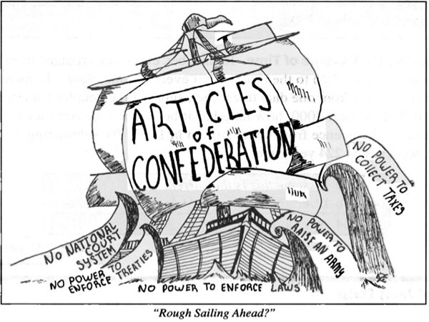

- What is the title of this cartoon? Rough Sailing Ahead.
- According to the cartoon, identify 3 actions the national government could not take under the Articles of Confederation.
No national court system, no power to enforce treaties, no power to enforce laws, no power to raise an army, no power to collect taxes.
- Explain how one of these actions could lead to problems in the future for the United States.
No power to raise an army could lead to problems in the future for the United States because the national government will not be able to ask the states to provide soldiers (draft )if they go to war with another country.

