Name__________________________________ Date_____________
Period____________ Unit 5 Day 1 Homework

Directions: When you finish reading the article below, answer the questions that follow on the back in COMPLETE SENTENCES.

Thomas Paine’s Common Sense

By 1775, the American colonists had moved closer and closer to a final break with Great Britain. Yet many colonists still were unwilling to separate from Britain. Then, in January 1776, a booklet called Common Sense helped the colonists decide on independence. In this reading, you will learn about Common Sense and about Thomas Paine, the man who wrote it.

Thomas Paine was born in England in 1737, the son of a Quaker clothing maker. Although he left school at age 13 to work in his father’s shop, he continued to educate himself by reading and studying. As a young man, Paine became a sailor and then worked at several different jobs.
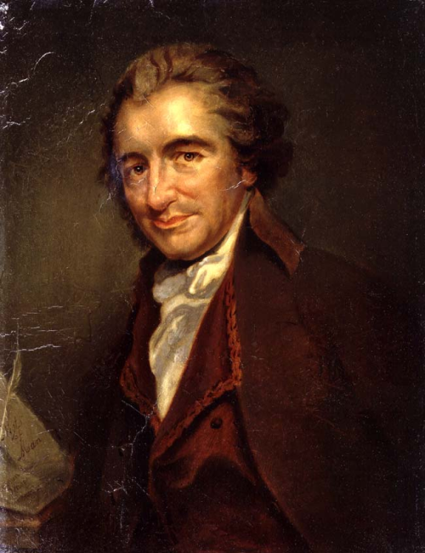
In 1774, Paine met Benjamin Franklin in London. Franklin encouraged Paine to visit America, and wrote a letter to help him when he arrived. Soon after arriving in America, Paine went to Philadelphia and took a job writing for several magazines. One of the first articles he wrote was about “the wicked practice” of slavery.
Thomas Paine had always been concerned with politics. In America, he immediately became interested in the colonists’ struggle with Great Britain. At first, he did not strongly believe in American independence. After fighting began at Lexington and Concord in the spring of 1775, however, he felt the colonies must become a free nation. He decided to write a short booklet urging Americans to fight for their freedom.
Paine’s work, Common Sense, appeared in January 1776. It was the first booklet to publicly urge Americans to seek their independence. Maybe because of this reason, Paine did not print his name on the booklet, although the colonists soon learned who had written it. During the next few months, more than 150,000 copies of Common Sense were printed and sold.
Paine’s Common Sense appeared just as the British were taking harsh measures against the colonists. Parliament had cut off all trade with the colonies. King George III, said that the colonists were in rebellion and sent hired Hessian troops, German soldiers who were hired to fight for the British, to America. Yet despite these actions, many colonists still felt they should try to settle their arguments with Britain peacefully. Even now, they still wanted to remain loyal to the British king.
Paine wrote Common Sense to stir up the colonists’ feelings. Above all, he hoped to make them see that they would never be able to reach a peaceful agreement with King George III. For this reason, Paine centered his attack on the king. He described King George III as a “royal brute” who planned to destroy the colonists’ rights. He pictured King George III as a bloody tyrant who did not deserve the loyalty of the colonists. Never before had the colonists dared to think of the British monarch in this way. In their hearts, many colonists felt that Paine was right. After Common Sense appeared, many people in the colonies began to accept the idea of independence.
DIRECTIONS: Answer the questions based off of the reading.

- Who did Thomas Paine meet in London that encourage him to visit America? Benjamin Franklin
- What event made Thomas Paine feel that the colonies must become a free nation? Battles of Lexington and Concord in the spring of 1775.
- Why did Thomas Paine write a short booklet after this event? He decided to write the booklet to urge Americans to fight for their freedom.
- What was the name of Thomas Paine’s first booklet? Common Sense.
- King George III said the colonists were in rebellion and he sent Hessian soldiers to America. Who were Hessians? German soldiers who were hired to fight for the British.
- Name two reasons Thomas Paine wrote Common Sense.
- Stir up colonists’ feelings.
- Make colonists see that they would never be able to reach a peaceful agreement with King George III.
- Who did Thomas Paine target in Common Sense and give an example of what he said about this person.
King George III. Described him as a “royal brute” who planned to destroy the colonists’ rights and as a bloody tyrant who did not deserve the loyalty of the colonists.
