Name______________________________ Date__________
Period___________ Unit 4 Day 1

DIRECTIONS: After we go over the individual slides, write down 2 important observations/facts about each document.

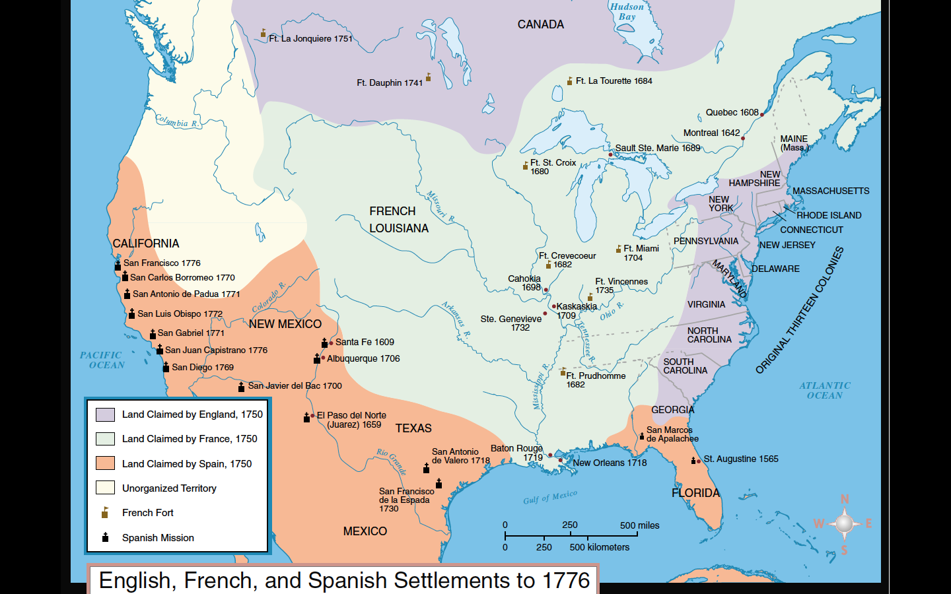
Document 1: English, French, and Spanish Settlements to 1776

- The French have control of the most territory in North America.
- There are forts (French) and missions (Spanish) along major water routes (rivers) and on the coasts.

Document 2: Population Chart comparing New France to the Thirteen English Colonies

Year | New  France |  | Year | Thirteen English Colonies
1628 | 76 |  | 1625 | 1,980
1641 | 240 |  | 1641 | 50,000
1688 | 11,562 |  | 1688 | 200,000
1713 | 18,119 |  | 1715 | 434,600
1754 | 55,009 |  | 1754 | 1,485,634
1760 | 70,000 |  | 1765 | 2,240,000

- The 13 Colonies (British) has a much larger population than New France, even though New France had more territory (as seen in Document 1).
- The population in the 13 Colonies (British) grew at a faster rate than the population of New France.

Document 3: Native American Tribes in the Northeast and Northern Midwest
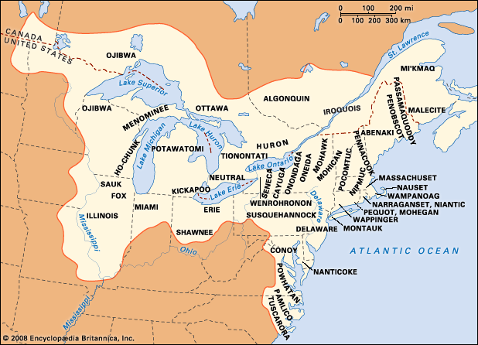

- There are many different Native American tribes in the Northeast and Northern Midwest.
- The Native American tribes claimed lands along water source (lakes, rivers, the coast).

Document 4: Movements in the Ohio River Valley

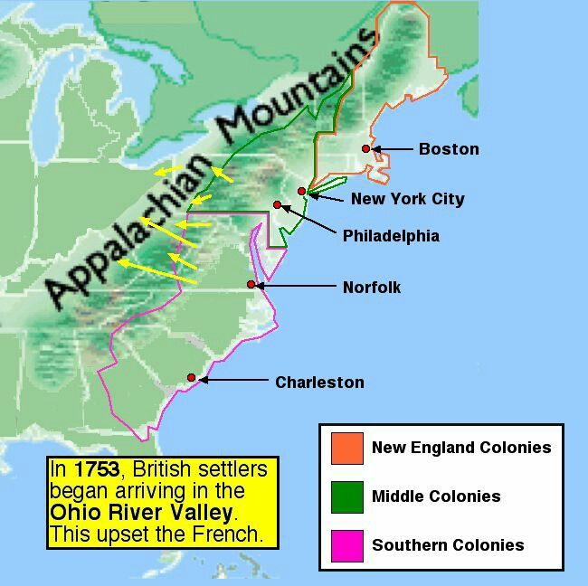

- Colonists from the Middle and Southern Colonies began to move west of the Appalachian Mountains.
- _The French were upset that British colonists began to settle in the Ohio River Valley (New France’s territory).

Document 5: Interactions Between Native Americans and Colonists
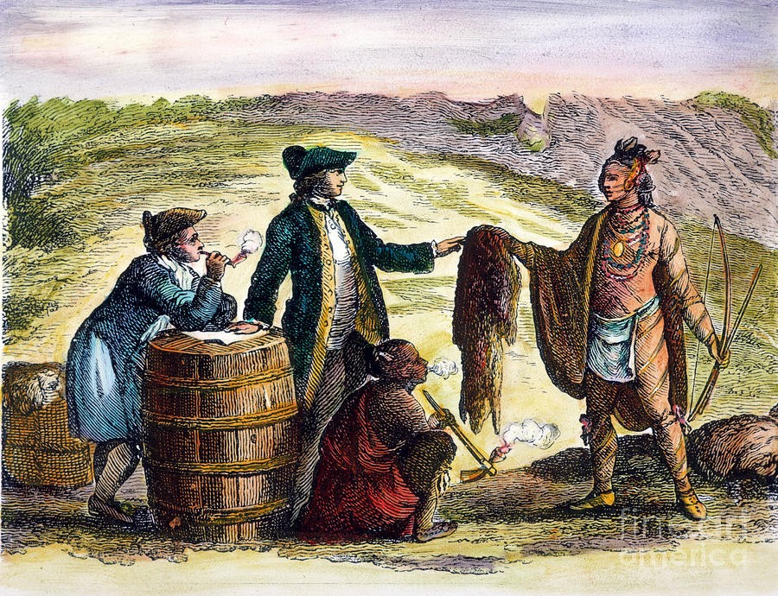

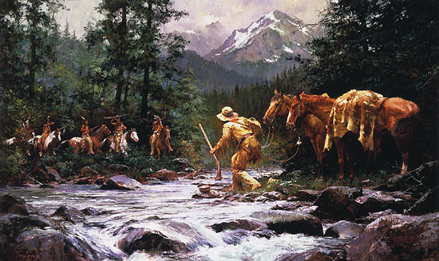

- Native Americans and European settlers traded in fur.
- Native Americans and European settlers sometimes had peaceful interactions (most likely the French, picture 1) and violent interactions (most likely the British, picture 2)

Document 6: Fur Trade Regions in North America
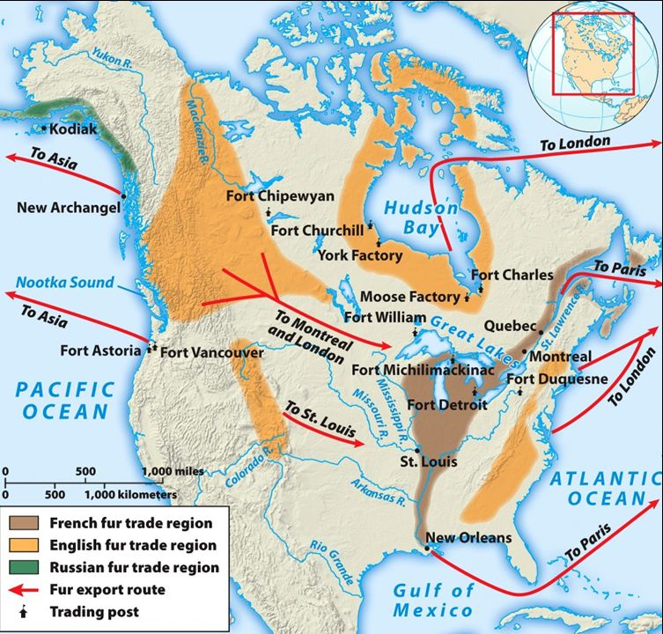

- The French fur trade region was in the Ohio River Valley and along the Mississippi River and St. Lawrence River.
- The English had more fur trade regions in North America.

