Name ______________________________ Date_________
Period ________ Unit 2 Primary Source Skills

Pocahontas: Fact or Fiction?
Disney’s Pocahontas aims to tell the story of how Pocahontas, a Native American from the area of present day Virginia, saved the life of John Smith, an Englishman who hoped to help with the creation of the English colony of Jamestown. For this skills lesson, we shall aim to uncover how much of this story is accurate and how much is a bold exaggeration of the events surrounding these two historic individuals.

The question we will focus on is: Did Pocahontas save John Smith’s life?

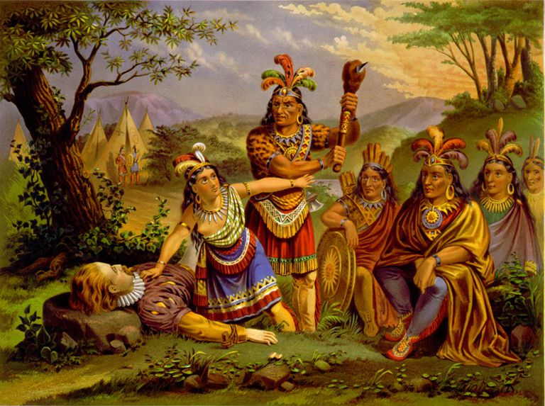

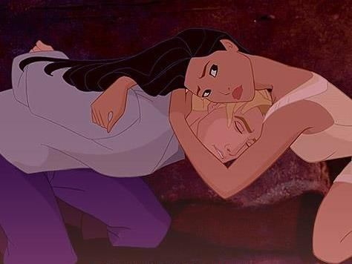

Document 1: “True Relation” (Modified)

“Arriving in Werowocomoco, the emperor welcomed me with good words and great platters of food. He promised me his friendship and my freedom within four days . . . He asked me why we came and why we went further with our boat . . . He promised to give me what I wanted and to feed us if we made him hatchets and copper. I promised to do this. And so, with all this kindness, he sent me home.”

Source: Smith’s own words, from A True Relation of such occurrences and accidents of note as hate happened in Virginia since the First Planting of the Colony. Published in 1608.

- Who wrote this account? John Smith
- When was this account published? 1608
- Summarize what happened when John Smith arrived in the village. (2 sentences)
When John Smith arrived in the village, the emperor welcomed him with kind words, food, and friendship. John Smith made them hatchets and copper in exchange for food. Smith and his crew were allowed to leave after a few days.
- Does this account show a positive and peaceful interaction or a negative and violent interaction between John Smith and the Natives? Explain using words from the account.
This account shows and positive and peaceful interaction with the Natives because they fed John Smith and his crew, were kind, let them go, and they promised friendship.

Document 2: “General History” (Modified)
“They brought me to Meronocomoco, where I saw Powhatan, their Emperor. Two great stones were brought before Powhattan. Then I was dragged by many hands, and they laid my head on the stones, ready to beat out my brains. Pocahontas, the King’s dearest daughter took my head in her arms and laid down her own upon it to save me from death. Then the Emperor said I should live.

Two days later, Powhatan met me and said we were friends. He told me to bring him two guns and grindstone and he would consider me his son.”

Source: From Smith’s later version of the story in General History of Virginia, New England and the Summer Isles. Published in 1624.

- Who wrote this account? John Smith
- When was this account published? 1624
- Summarize what happened when John Smith arrived in the village. (2 sentences)
When John Smith arrived in the village, he was brought before the chief, dragged to the ground, put his head on the stones, and got ready to beat out his brains. Then he was saved by the chiefs daughter, Pocahontas, and the chief said he could leave and was now his son, as long as he brought him two guns and a grindstone.
- Did John Smith’s account of what happened in the village change over time? Explain how the account changed from Document 2.
Over time, John Smith’s account changed over time and became more violent and dangerous. In the second account, the Natives were about to kill him, but Pocahontas saved him. In the first account, they were peaceful and friendly.

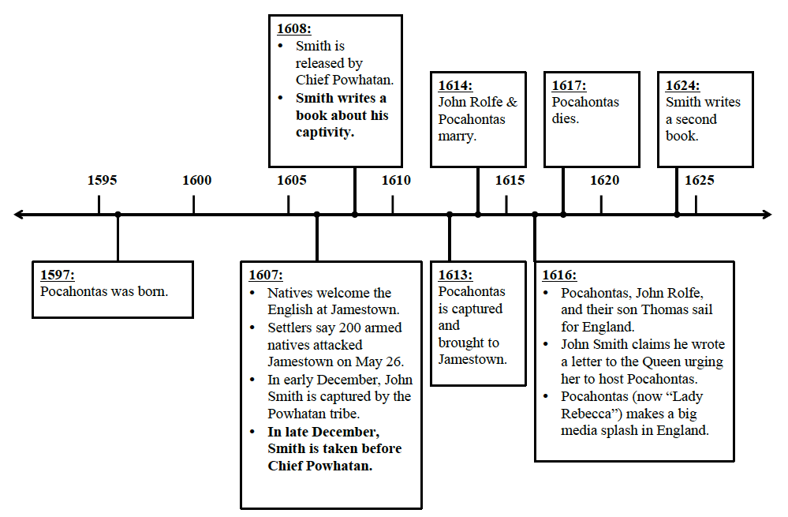
Document 3: Below is a timeline of the events between Pocahontas and John Smith. Using the timeline and your answers from Documents 1 and 2, answer the questions below.

- What happened in 1616 and 1617 that might make the story of Pocahontas and John Smith interesting?
In 1616, Pocahontas came to England and she became very popular in the media. In 1617, Pocahontas died. Because she was so popular in the media, more people would want to learn about her and what happened when John Smith met her.
- Why might Smith lie or exaggerate and invent new information?
Smith might lie or exaggerate and invent new information in order to become more popular for having met Pocahontas. He would have made money off of telling his story.

