Name ______________________________ Date_________

Period ________ Unit 2 Day 2 Homework

DIRECTIONS: Read the passage below, highlight or underline key words and facts, and answer the questions that follow.

The Northwest Passage

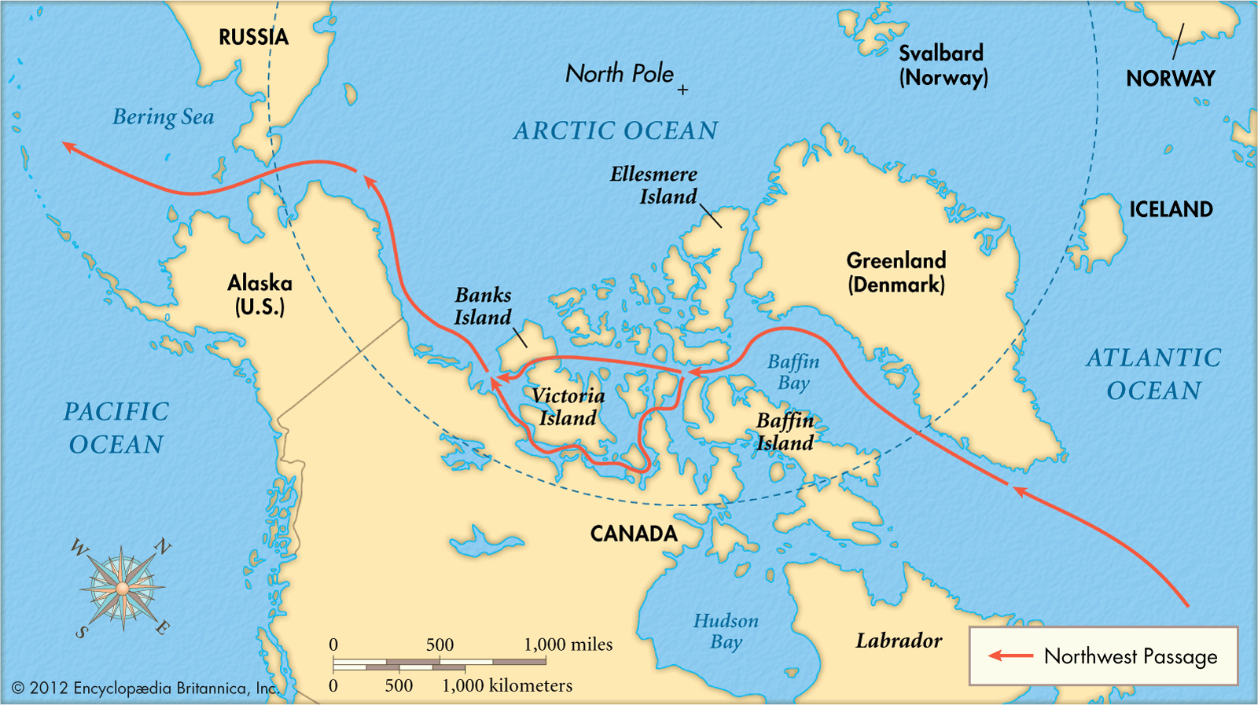
The English, for their part, tried to gain control of much of North America, hoping—as did the French and the Dutch (Holland)—to find the Northwest Passage, a water route to Asia that European mapmakers were convinced existed somewhere in North America. Since Europeans had fallen in love with East Asian silk as well as the cinnamon, cloves, nutmeg, and peppers, these sixteenth-century (1500s) explorers knew there was enormous demand for whatever they could bring back. The Northwest Passage would, in theory, cut the length of the journey, thus ensuring that the spices would be fresher than those brought around Africa or South America. A quick water route would also allow northern Europeans to cut off both the Spanish, and the Portuguese, who reached the Pacific by sailing around Africa and then across the Indian Ocean.
John Cabot looked for a northern route to Asia in 1497. About 100 years later, England funded (paid for) an expedition (trip) to continue the search. The English did not want conflicts with Spain and Portugal in the southern parts of the continent. Instead, they focused on exploring northern routes. In 1607, Henry Hudson sailed west on behalf of the English. He hoped to find a “Northwest Passage.” He believed the ice of the northern seas would melt during the summer. When the ice melted, he could cross to the north of the American continent. From there, he would reach Asia through a Northwest Passage. Hudson had the experience and maps of previous northern explorers. Still, ice and winds made him turn around. When a second attempt also failed, the English abandoned the project.
Hudson needed a new source of funding, so he went to England’s rivals, the Dutch. The Dutch East India Company agreed. On his third voyage, Hudson set a course south along the North American coast. Hudson discovered New York Bay, and then followed a wide river. He hoped the river would lead to the Pacific Ocean. But the river became narrow and shallow and turned to fresh water. Hudson turned around once more. On the way downstream, he explored the shores and traded with the Algonquin Indians. We now call this river the Hudson River.
The Dutch refused to pay for another voyage. Hudson convinced England to support one more expedition. His fourth and last voyage led to the discovery of Hudson Bay in 1610. When winter came, his ship became trapped in ice. The expedition was stranded on the shore of the bay until the spring thaw. When spring came, Hudson wanted to explore further, but his crew were fed up. They set Hudson and some supporters adrift in a boat in the bay and sailed the ship back to England. Hudson was never seen again.
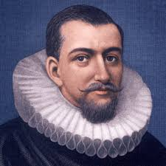
The difficult travels of explorers such as Hudson helped the Europeans settle North and South America. Hudson made a clear map of the eastern and northern sections of North America.
DIRECTIONS: Answer the questions below based on the reading.

- Define Northwest Passage.
The Northwest Passage a water route to Asia that European mapmakers were convinced existed somewhere in North America.
- Why did Europeans want to find a Northwest Passage?
Europeans wanted to find the Northwest Passage so that they could make money faster trading for Asian spices and goods by cutting the journey in half. Northern Europeans hoped to cut off the Spanish and the Portuguese on their way to the Pacific Ocean.
- Why did Henry Hudson think he could find the Northwest Passage?
Henry Hudson thought he could find the Northwest Passage because he believed the ice of the northern seas would melt during the summer. When the ice melted, he could cross to the north of the American continent. From there, he would reach Asia through a Northwest Passage.
- What happened to Henry Hudson on his 4th voyage?
On Henry Hudson’s 4th voyage, he discovered Hudson Bay in 1610. When winter came, his ship became trapped in ice. The expedition was stranded on the shore of the bay until the spring thaw. When spring came, Hudson wanted to explore further, but his crew were fed up. They set Hudson and some supporters adrift in a boat in the bay and sailed the ship back to England. Hudson was never seen again.

