Name ______________________________ Date_________
Period ________ Unit 2 Day 2

Aim: How did the European powers divide up the “New World” they found?

DIRECTIONS: Using the chart below, answer the questions on the next page.

Explorer | Country Sailed  From | Dates of  Exploration | Achievements
Bartolomeu Dias | Portugal | 1487-1488 | Sailed around the southern tip of Africa
Vasco da Gama | Portugal | 1497-1498 | Sailed around Africa to India
Pedro Alvares Cabral | Portugal | 1500 | Reached Brazil
Christopher Columbus | Spain | 1492-1504 | Explored the West Indies and the Caribbean
Vasco Núñez de Balboa | Spain | 1513 | First to view the Pacific Ocean
Juan Ponce de León | Spain | 1508-1509, 1513 | Explored Puerto Rico and Florida
Ferdinand Magellan | Spain | 1519-1522 | Led the first expedition to sail around the world [circumnavigate]
Pánfilo de Narvárz / Cabeza de Vaca / Estevanico | Spain | 1528-1536 | Traveled in the Spanish borderlands
Francisco Coronado | Spain | 1540-1542 | Explored southwestern North America
Hernando De Soto | Spain | 1516-1520,  1539-1542 | Explored Central America and led expedition to the Mississippi River
Juan Cabrillo | Spain | 1542-1543 | Explored the west coast of North America
John Cabot | England | 1497-1501(?) | Explored the east coast of North America
Henry Hudson | England | 1610-1611 | Explored Hudson Bay
Henry Hudson | Netherlands | 1609 | Explored the east coast of North America and the Hudson River in New York
Giovanni da Verrazano | France | 1524 | Explored the east coast of North America, including present-day New York harbor
Jacques Cartier | France | 1534-1542 | Explored the St. Lawrence River
Samuel de Champlain | France | 1603-1615 | Explored the St. Lawrence River valley & founded Quebec
Jacques Marquette /  Louis Joliet | France | 1673 | Explored along the Mississippi River
Robert de La Salle | France | 1679-1682 | Explored the Great Lakes and reached the mouth of the Mississippi River

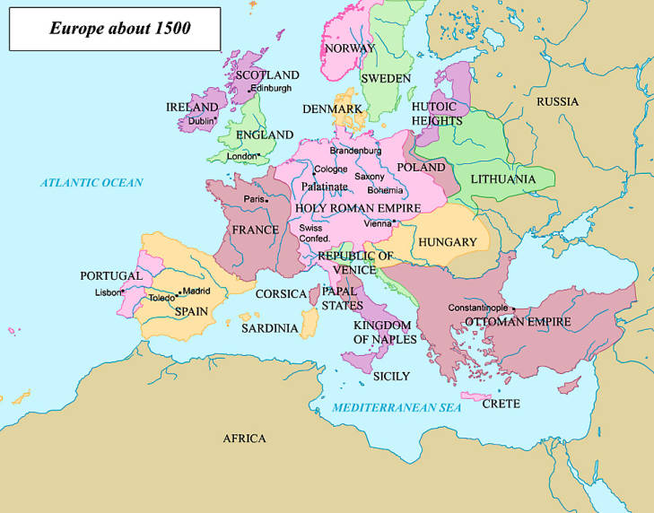

DIRECTIONS: Using the chart, answer the questions below.

- Which countries sent Explorers to discover and claim land in the New World? Portugal, Spain, the Netherlands, England, and France.
- Which country was the first to send out Explorers? Portugal
- Which country sent out the most Explorers? Spain
- Which Explorer was sent out by two different countries? Henry Hudson
- Which Explorers discovered and explored land in present day New York? Hudson and Verrazano
- Which explorer was the first to circumnavigate the world? Ferdinand Magellan
- Which explorer was the first to view the Pacific Ocean? Vasco Núñez de Balboa

