Name ______________________________ Date_________
Period ________ Unit 2 Day 1 Homework

DIRECTIONS: Below you will find a reading passage about the reasons behind early exploration. Highlight key words and important information as you read. Then, answer the questions that follow.

Reasons for the Age of Exploration
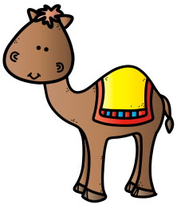
For centuries, the trading of goods happened between European and African Empires. Trading between Asia and Europe took place along the Silk Road, a network of land and sea trade routes. This time period is often referred to as the Age of Exploration. Trade along the Silk Road increased, and knowledge, artistic expression, and scientific discovery in Europe expanded.
Many new kingdoms throughout Europe continued to grow and increase in power in their region, leading to conflicts between kingdoms as the competition for land and wealth increased. One example of this was the Hundred Years War, a series of conflicts between England and France in the 1300s and 1400s. Many European kingdoms felt trading with Africa and Asia was a way to increase wealth (money) and gain advantages over their rivals.
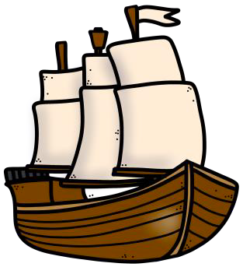
Trade along the Silk Road was tightly controlled by empires in the Middle East. They blocked trade between the rest of Europe and Asia. Europeans were forced to buy Asian goods from the two Italian cities, leading to high prices and a shortage of goods. Understandably, European kingdoms were not happy with this situation and wanted a way to trade directly with Asia. In order to do this, they had to find a way around the Muslim empires in the Middle East. Many leaders thought the best way to do this was to find a sea route to Asia allowing them to avoid the traditional Mediterranean Sea routes under Middle Eastern control. European explorers started taking long voyages, or trips, in search of a sea route to Asia during the Age of Exploration.
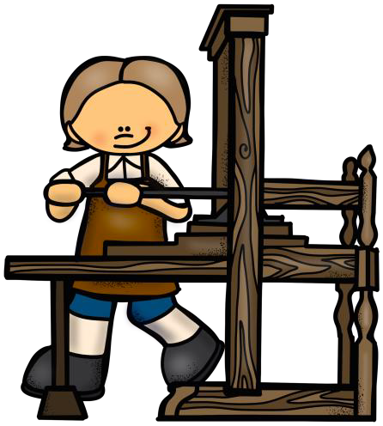
Trade was the primary reason behind the first European journeys, but there was another strong motivating factor for continuing European expansion. Christianity was a popular religion throughout Europe during the Age of Exploration. One way Christianity led to exploration was because members wanted to try converting others who did not believe in Christianity to their religion. Trading posts and colonies started appearing in Africa, and missionaries, people on a church mission to educate and convert others, started traveling with merchants and explorers. Leaders of many European kingdoms approved and supported the missionary work going on in Africa. Leaders believed creating colonies to spread faith in their name and kingdom showed their devotion to God and increased their power.
All of this new information, knowledge, and adventure was heard by thousands of people thanks to the printing press. In 1450, Johannes Gutenberg invented the printing press, an innovation allowing books to be printed faster and distributed farther than ever before. Maps and information about seafaring technology spread throughout Europe quickly. Education became an important part of the navigational success during the Age of Exploration.
DIRECTIONS: Using the words in the boxes below, write each term with its description.
Asia | Silk Road | Age of Exploration
Christianity | Mediterranean Sea | Printing Press

- Time period that led to an increase in exploration and trade: _________________________________________________
- Body of water controlled by Middle Eastern empires, that Europeans tried to avoid: ____________________________________________________
- Main religion of Europe during the Age of Exploration: _____________________________________________________
- Network of land and sea trade routes between Asia and Europe: __________________________________________
- Europeans wanted to find an all-sea route to the continent of ___________________________ for trade without any conflicts from other empires.
- This invention led to maps and information spreading more quickly:
________________________________________

