Name____________________________ Date__________
Period_________ Unit 7 Day 5

Document 3: The XYZ Affair
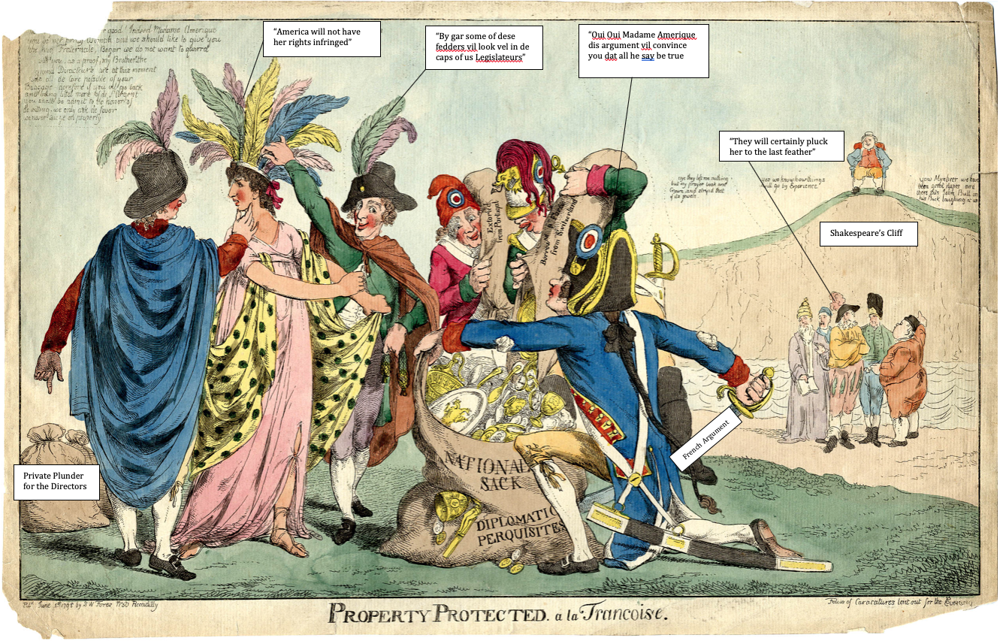
After becoming president, Adams tried to solve the problems with France. The French took over American ships they thought were trading with Britain. Adams wanted to end these attacks. In 1797, Adams sent a group of diplomats to France. They were to meet with the French foreign minister Charles-Maurice de Talleyrand.
When the U.S. representatives arrived, Talleyrand would not meet with them. Instead, a group of three French agents met them. These agents wanted the Americans to pay bribes for a meeting with Talleyrand. They asked for $250,000 for Talleyrand, plus a loan to France of $10 million. The diplomats refused to pay the bribes. They sent word about the meeting to Adams. Adams was very angry, so he reported the news to Congress. When discussing the problem, diplomats and Adams called the bribers Agents X, Y, and Z. For this reason, the event became known as the XYZ Affair.
The XYZ Affair angered Federalists in Congress. They had never had good feelings about France. They wanted war. Adams continued to try for peace. In 1800, the United States and France signed a peace treaty that said the two countries were trading partners.

- What event is being shown in the cartoon? The XYZ Affair
- Who do the men in the cartoon represent? The French agents that met with the US diplomats.
- Who does the women in the cartoon represent? The United States
- What did the French agents demand the US diplomats give them before they would speak with them about ending the attacks on US ships?
They asked for $250,000 for Talleyrand, plus a loan to France of $10 million.
- How did the Federalists respond to the demands?
The Federalists were angry and wanted Adams to ask Congress for a declaration of war.
- Using the cartoon, identify the cartoonist’s point of view of the XYZ Affair. (THINK ABOUT: How does he/she view the French as a result of the terms of negotiation involved in the XYZ Affair.
The cartoonist thinks that the French were trying to take advantage of the Americans by asking for bribes.

