Name__________________________________ Date__________________
Period______________ Unit 4 Day 4
The Proclamation Line of 1763
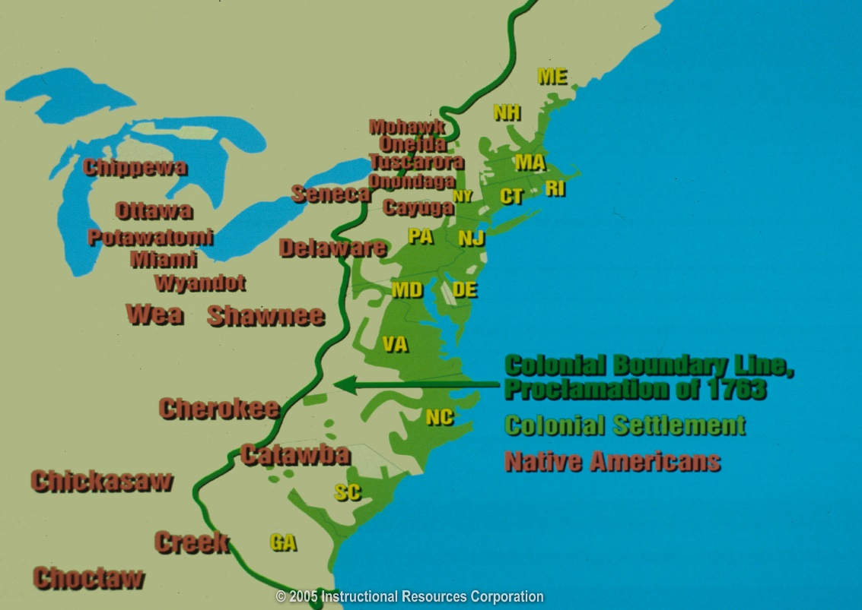
When the French and Indian War ended, King George III had a difficult choice. How should he handle the colonists’ demands to move westward into Native American territories? Granting the colonists the right to move would make them happy. It would also stir up conflicts with Native Americans. Providing the colonists with protection was expensive. Protection would require the presence of British soldiers.

King George III decided that the best way to solve the problem was to limit settlement. He issued the Proclamation of 1763. This order created a line beyond which American colonists could not settle. The lands beyond the line were reserved for Native Americans. The Proclamation angered the colonists – they had already claimed land in the west and had to pay for the additional British troops sent from England. Many settlers ignored the Proclamation and moved there anyway.
Directions: Using the reading passage and map above, complete the chart
1763- The Proclamation Line
BRITISH ACTION
- Limit settlement.
- Colonists could not cross boundary line and settle west of the Appalachian Mountains.

COLONISTS REACTION
- Angered colonists.
- Settlers ignored the boundary, went west anyway.

