Name____________________________ Date__________
Period_________ Unit 7 Day 4

Document 2: The Pinckney Treaty

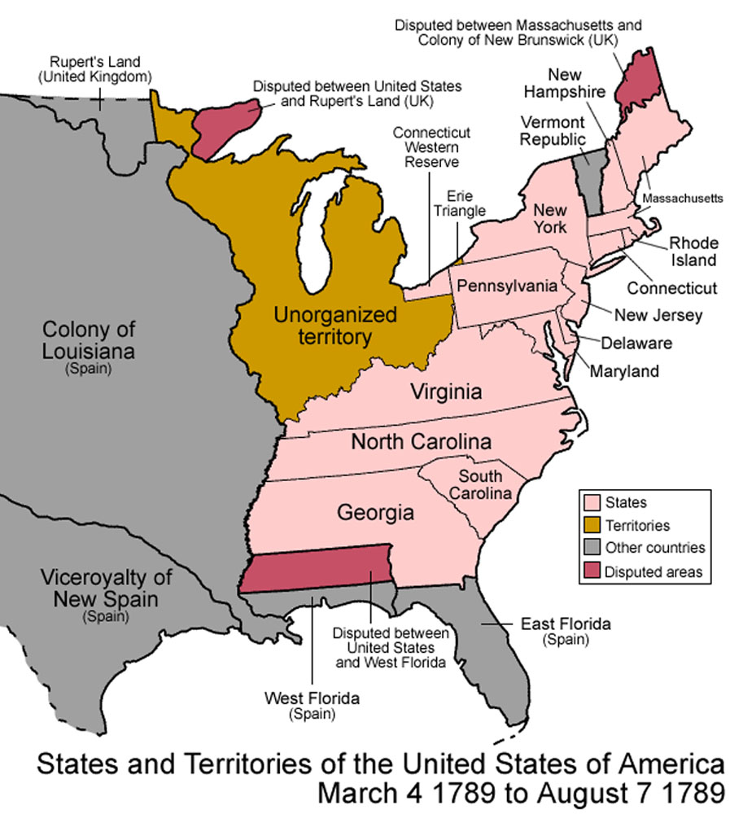
Washington’s Cabinet also had to settle border problems with Spain. Spain controlled the land west of the Mississippi River after the Revolutionary War. However, the US and Spain disagreed on who controlled the land between the Mississippi River and Florida (known as West Florida). Because of this disagreement, Spain threatened to cut off American shipping on the Mississippi River. This would greatly hurt the US’ ability to ship goods North and South in the western frontier.
President Washington sent Thomas Pinckney to talk with Spain. There, Pinckney established a treaty securing the intentions of friendship between the United States and Spain. It also defined the boundaries of the U.S. with the Spanish colonies and guaranteed U.S. navigation rights on the Mississippi River. President Washington’s strong stand led to successful outcomes. The results seemed to support Hamilton’s ideas about the proper uses of federal power.

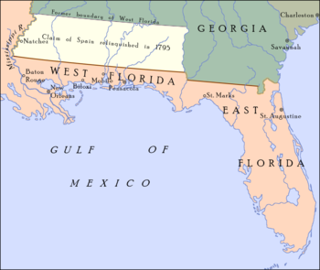
- What country controlled the land west of the Mississippi River? Spain
- What did Spain and the US have a disagreement about?
The US and Spain disagreed on who controlled the land between the Mississippi River and Florida (known as West Florida).

- How did the Spanish threaten the United States?
Spain threatened to cut off American shipping on the Mississippi River.
- How would this hurt the United States?
This would greatly hurt the US’ ability to ship goods North and South in the western frontier.
- Name two ways the Pinckney Treaty fixed the relationship between Spain and the United States?
It defined the boundaries of the U.S. with the Spanish colonies and guaranteed U.S. navigation rights on the Mississippi River.

