Name____________________________ Date__________
Period_________ Unit 7 Day 4

DIRECTIONS: Answer the following questions based off of the reading and images.

Document 1: The Jay Treaty

Late in 1793, Great Britain broke U.S. neutrality by taking U.S. ships by force. The British practiced a policy of impressment. Impressment refers to the act in which men were captured and forced into naval service. American soldiers were taken from ships and forced to work in the British navy. The British took the American ships that were trading with the French colonies in the West Indies. Many Americans were angry. They thought the United States should declare war on Britain. Hamilton was worried because his economic plans depended on trade with Britain. He asked Washington to send Supreme Court Chief Justice John Jay to represent the United States in talks in London.
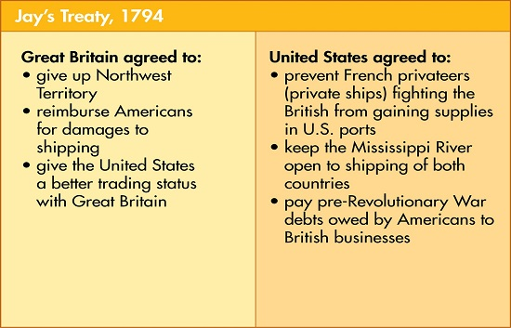
In November 1794, the two sides agreed to what became known as Jay’s Treaty. The details of the treaty are shown here in this chart.

- What does “neutrality” mean? Not pick a side in a conflict.
- Define “impressment.” The act in which men were captured and forced into naval service.
- Why did the British take the American ships?
The British took the American ships that were trading with the French colonies in the West Indies.
- Using the chart, describe what the British agreed to do under the Jay Treaty.
The British agreed to give up claims to land in the Northwest Territory, pay for damages, and give the US better trading status.
- Using the chart, describe what the United States agreed to do under the Jay Treaty.
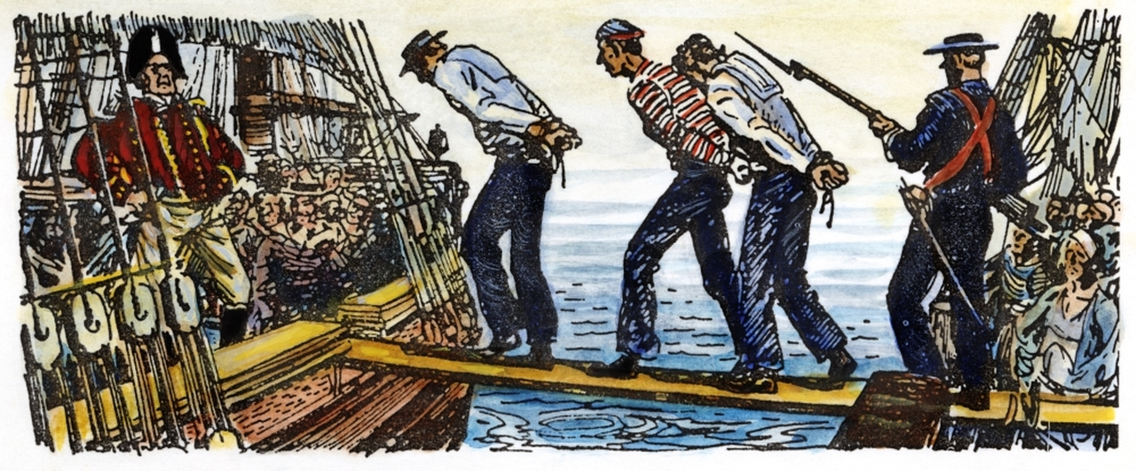
The US agreed to pay debts fromt before the Revolutionary War, allow the British to use the Mississippi River, and stop the French from attacking Brtiish ships that traded with the Americans

