Name________________________________ Date____________________
Period_______________ Unit 1 Day 6

The First Americans
Covered in ice! Land Bridge!

According to this historical map, where did human beings supposedly originate from? Africa
What were the last continents to be inhabited by early humans? South America, Australia

Name the area in between the western tip of Alaska and eastern portion of Siberia? Bering Land Bridge
Could a person swim across this distance? Why or why not? Multiple answers, just make sure you back up your argument!
How might people have been able to cross the Bering Strait by foot? Walking, animals, camping etc.

- Polynesians travel from New Guinea to Hawaii, which is over 4,000 miles, in boats that are very similar to canoes in the open ocean.

What is this map showing us? The World, physical geography. (mountains, rivers, ocean floor)

What are these “bumps” in the oceans? Ocean floor elevation.

The Bering Land Bridge
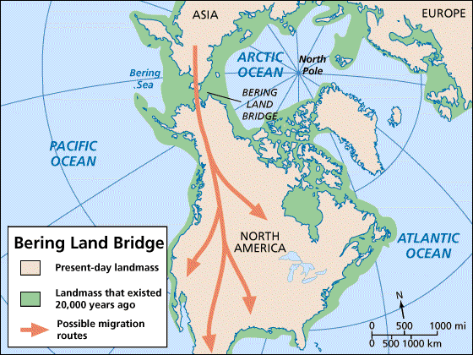

From this map you can see where a strip of land across the Bering Sea connected Asia and North America during the last Ice Age. The first humans came to the Americas from Asia across this land bridge, perhaps in search of large game animals. Scholars estimate that this migration took place somewhere between 14,000 and 50,000 years ago. When the Ice Age ended around 7,000 B.C., melting glaciers raised the level of the seas so that water covered the land bridge.

30,000 years ago, the Earth was in an Ice Age. The ocean levels on Earth were much lower because more of the waters of the ocean were frozen in the poles. Exposed the ocean floor at shallower depths.

Exit Ticket

DIRECTIONS: Answer the following question in 5-8 sentences. Be sure to you some evidence or ideas discussed during today’s lesson.

Do you think that the first people who came to America would have the same culture 100 years after they arrived? Why or why not?

____________________________________________________________________________________________________________________________________________________________________________________
____________________________________________________________________________________________________________________________________________________________________________________
____________________________________________________________________________________________________________________________________________________________________________________
____________________________________________________________________________________________________________________________________________________________________________________
____________________________________________________________________________________________________________________________________________________________________________________

