Name_____________________________________ Date__________________
Period________________ Unit 8 Day 2

Opportunity Knocks – Jefferson Responds

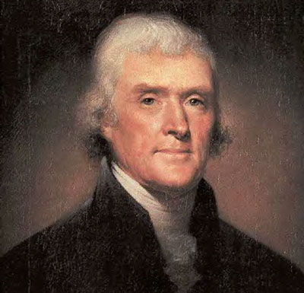
Never had an opportunity like this come to the United States, and Jefferson knew it, but it troubled him anyway. Here was a chance to buy 827,000 square miles of real estate, rid the nation of a dangerous neighbor, and allow room for expansion to the crest of the Rocky Mountains. It had come about in this way: France had lost its territory, known as Louisiana, to Spain in 1763, but French pride had been hurt in the process. In 1800, Napoleon had put pressure on Spain to return it, and the two nations had made a secret treaty whereby France would take it back whenever they chose. American diplomats heard rumors of this deal in 1801.
People didn’t know much about Louisiana at the time. There were only a few settlements, like St. Louis, on its eastern fringe, but what it held in rivers, minerals, animals, and agricultural potential was anyone’s guess. It was known there were many Indians there, but their numbers and friendship were yet to be discovered. What was known was this: in the hands of Spain, Louisiana was no threat to western development. But if France moved back in, it could block American expansion and, at worst, become a danger to the United States. Jefferson told American diplomats to use whatever means they could to prevent the transfer from Spain to France.
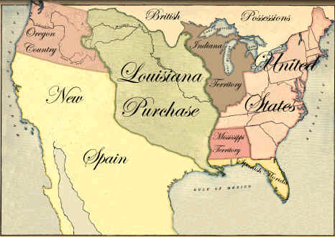
That need was stressed when the Spanish governor at New Orleans issued an order that would prevent Americans from depositing their goods at New Orleans while waiting for ships to transport them to world markets. Frontiersmen suspected the French were behind this and were willing to take steps to seize New Orleans. To calm them down, Jefferson sent James Monroe to Paris with instructions to buy New Orleans and Florida if France owned them. Before Monroe arrived, Napoleon had already decided to sell Louisiana. He had hoped to use it to feed the people of Haiti, while they produced sugar and tropical fruit for France. His plan had fallen through. Led by Toussaint L’Ouverture, the Haitians had destroyed a French army sent to control them. Without Haiti, Napoleon did not need Louisiana.
The price agreed on was $15,000,000, one-fourth of which was to pay damage claims by Americans against the French. But the deal bothered the president’s conscience. No specific authority had been given by the Constitution to buy land, and he had always opposed stretching the language of the Constitution. He thought about seeking a constitutional amendment, but Monroe advised him that Napoleon would back out if they delayed. The temptation was too strong, and Jefferson took the offer to Congress. It approved the treaty and the money. Louisiana now belonged to the U.S.
DIRECTIONS: Answer the following questions about the selection you have just read. Be sure to incorporate the question into your answers, aka WRITE IN COMPLETE SENTENCES!

- What were the benefits to the U.S. of obtaining Louisiana?
The benefits were it was a chance to buy 827,000 square miles of real estate, rid the nation of a dangerous neighbor, and allow room for expansion to the crest of the Rocky Mountains.

- Why did the U.S. want to prevent France from regaining control of New Orleans and the rest of Louisiana?
The U.S. wanted to stop France from controlling Louisiana because if France moved back in, it could block American expansion and, at worst, become a danger to the United States.

- How did Toussaint L’Ouverture inadvertently (without realizing) help the U.S.? Toussaint L’Ouverture helped by defeating the French army in Haiti. By doing that, it made Louisiana useless to Napoleon.

- Why did the deal with France bother Jefferson’s conscience?
The deal bothered Jefferson because no specific authority had been given by the Constitution to buy land, and he had always opposed stretching the language, or powers, of the Constitution.
- Why did Jefferson go ahead with the deal despite his concerns?
Jefferson went ahead with the deal despite his concerns because Monroe advised him that Napoleon would back out if they delayed taking the deal.

- A strict constructionist believed the United States could only do what the Constitution specifically allowed. A loose constructionist believed the U.S. could do whatever was “necessary and proper” to carry out its responsibilities listed in Article I, Section 8, of the Constitution. Was Jefferson’s purchase of Louisiana an example of strict construction or loose construction? Why? Jefferson’s purchase of Louisiana is an example of loose construction. The Constitution did not list acquiring land as a power of Congress but allowed it to make treaties. That authority was enough to convince Jefferson.

