Name_______________________________ Date___________
Period___________ Unit 8 Day 2 Skills

DIRECTIONS: Read the following information about the election of 1800 and study the “Mad Tom” Cartoon. Then answer the questions that follow.

Jeffersonian Republicans Won the Presidency

In the early years of the American republic, members of the political parties often attacked each other with vicious accusations of treason, immoral behavior, and criminal activity. Sometimes they attacked one another physically. In February of 1798, for example, a Federalist and a Democratic Republican in Congress fought with weapons on the floor of the House of Representatives. After the XYZ Affair, the Federalists used the outrage against France to pass the Alien and Sedition Acts. These laws were used to expel foreigners and immigrants who favored the Republicans and to imprison or fine publishers, politicians, and other citizens who criticized the government under the Federalists. Fortunately for the Jeffersonian Republicans, some Federalists attacked their own president, John Adams. The only leader not attacked, even though he became identified with the Federalist party, was George Washington, who died in 1799.
The years leading up the election of 1800 were marked by bitterness, in 1798 Jefferson and James Madison drafted protests called the Virginia and Kentucky Resolutions that claimed a state’s right to nullify federal laws. Each political party accused the other of betraying the Constitution, the American Revolution, and the United States. Jefferson, however, won the presidency when Hamilton and other Federalists attacked Adams and split the Federalists vote. Jefferson and his Republican running mate tied in the electoral vote. The House of Representatives resolved the dilemma early in 1801. Jefferson became president and replaced many Federalists in the government with Republicans. A peaceful transition from a party in power to an opposition party was accomplished without any threat to the government or the Constitution.

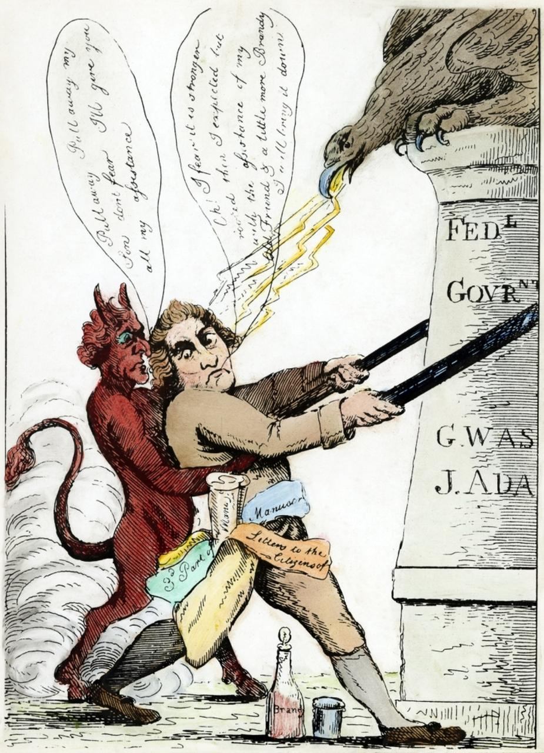
“Oh!” I fear it is stronger rooted than I expected but with the assistance of my old Friend a little more brandy, I will bring it down.”
“Pull away, Pull away my Tom, don’t fear. I’ll give you all of my assistance.”
DIRECTIONS: Answer the following questions based off of your knowledge of social studies and the cartoon.
- Who is helping Jefferson, according to the cartoonist? The Devil
- Whose names appear on the pillar? George Washington and John Adams
- What does the pillar itself represent? Federal government
- Who or what is defending the government in the cartoon? Eagle, large bird
- What does Jefferson appear to be trying to do in the cartoon? Taking down the federal government.
CRITICAL THINKING
- Determining Relevant Information: Why would the cartoonist suggest that Jefferson is attacking the government? How would Jefferson’s actions or beliefs support this?
Thomas Jefferson wanted to limit federal power. Jefferson got rid of federal taxes, reduced government spending, and reduced the number of federal employees.
- Demonstrating Reasoned Judgement: What elements in the cartoon would support the idea that the cartoon is an example of political propaganda* against Jefferson?
The cartoonist is trying to make Jefferson look crazy and evil. Using the devil as his assistant, the cartoonist is showing that Jefferson is friends with the Devil and taking evil actions. Using the brandy, the cartoonist is showing that Jefferson is not thinking clearly and making bad decisions because he is drinking alcohol.
*Propaganda: a form of communication to distribute information. It is always biased. The information is designed to make people feel a certain way or to believe a certain thing. The information is often political.

