Name ______________________________ Date__________
Period ________ Unit 4 Day 2

Directions: Look at the quote and drawing and answer the following questions.

“Everyone cries a union is necessary. But when they come to their manner and form of the union, their weak noodles are perfectly distracted.”
-Benjamin Franklin
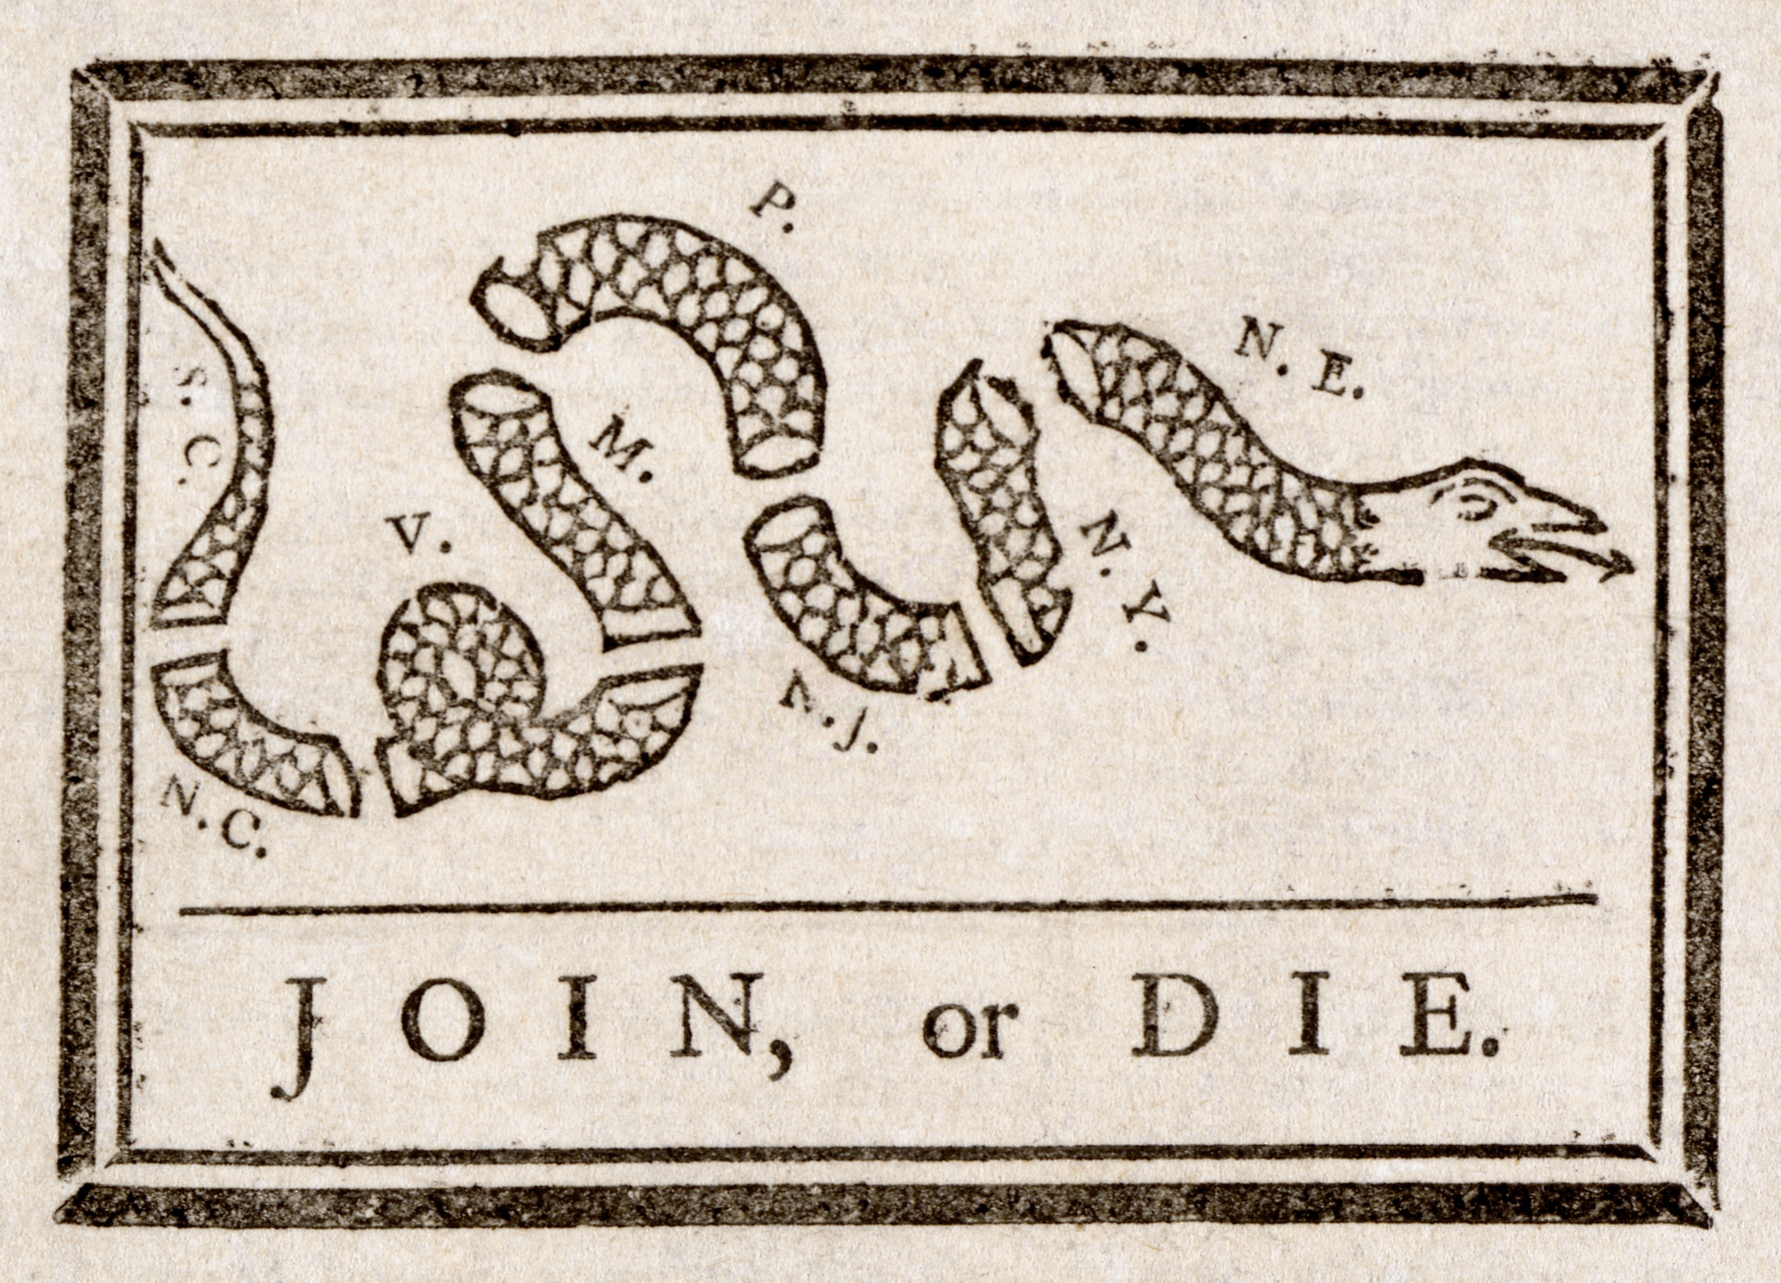
The picture to the side is an engraving made by Franklin in the Pennsylvania Gazette. It shows his attitude toward the failure of the Albany Plan of Union – a council of representatives elected by the colonial assemblies. It would organize armies and collect taxes to pay its expenses. The colonial assemblies rejected the plan. The colonies wanted to control their own armies and taxes.

- What do each of the single or paired initials in the cartoon stand for?
Each colony except Georgia. NE = New England.
- What danger to the colonies prompted Franklin to publish this cartoon?
They were fighting a war with France.
- What do you think Franklin is saying with this picture? (the main idea)
Join together to fight or lose the war. Join OR Die – join together to fight the French under a plan of union, or the French will defeat them.
- What assumption does Franklin make in the cartoon about the strength of the individual colonies?
That the colonies standing alone are weak.

