Name______________________________ Date__________
Period___________ Unit 4 Day 1 HW

European Rivalries, Native American Loyalties, and the Ohio River Valley
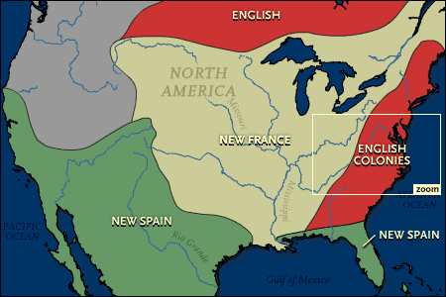
By 1750, France held even more territory in North America than Great Britain. France controlled much of the land to the west and north of Britain’s 13 colonies. The French had developed a valuable fur trade. They enjoyed fairly peaceful interactions with the Native Americans who lived throughout the area.
Back in Europe, Britain, France, and Spain had been involved in on-and-off wars with one another for many years. The rivalry between these nations extended to America. Britain and France competed to extend their colonies’ borders to the Ohio River Valley and throughout the Great Lakes. This area was important. The Ohio River offered a water route all the way to the Gulf of Mexico.
To increase control of the region, the French attacked English settlers. Then, they forcibly evicted them, or removed them, from the area. They also began building forts throughout the valley. In 1754, the British sent a young officer named George Washington to the region to settle these issues. Washington warned French colonists to stay clear of British-claimed territory in what is now western Pennsylvania. The French refused. Washington returned from his mission with the news. So, the British sent soldiers to the area.
The conflict erupted into the French and Indian War. For nearly a decade, Britain and its American colonists were locked in a military struggle with France and its colonists. The war was fought by British troops from England and from the colonies.
A large number of Native Americans lived in the disputed territories. They found themselves drawn into the war. Although their loyalties were divided, most Native Americans sided with France. French fur traders had developed friendly relations with Native Americans. The British were interested in establishing large, permanent settlements in America. The French were not as interested in permanent settlements.
Some Native American groups sided with the British in the French and Indian War. Two factors pushed most of the six Iroquois nations to fight alongside the British. First of all, the Iroquois had long been enemies of the Algonquin and the Huron. The Algonquin and Huron were closely allied with the French. Second, the Iroquois had a history of poor relations with the French. Back in the 1740s, the French had tried to force British settlers out of the Ohio area. They raided British settlements. They ordered the Iroquois not to trade with the British. The Iroquois had good relations with the British and resented these French policies. The Iroquois who did side with France, changed their allegiance to Britain after 1760.

DIRECTIONS: Answer the questions using the information from the reading.

- In 1750, who had control of most of the land in North America? France
- What area, or region, did the British and French begin to push into? The Ohio River Valley
- Why did they want control of that area? The Ohio River offered a water route all the way to the Gulf of Mexico.
- Why did the British send George Washington into the Ohio River Valley to talk with the French? (2 reasons)
The French were attacking English settlers in the Ohio Territory, forcing them to leave, and the French were building forts throughout the valley.
- Why did more Native Americans have friendly relations with the French than the British? (hint: think settlements)
The French were not interested in permanent settlements and they had a good relationship because of the fur trade.
- Why did the Iroquois side with the British in the French and Indian War?
The Iroquois had poor relations with the French and their enemies, the Algonquin and Huron, sided with the French.

