Name ___________________________________________________
Period _______

Date of assessment______________
1. Type of assessment (circle one): quiz test current event project
2. How satisfied were you with your results? (circle one) Very satisfied Satisfied Unsatisfied Very Unsatisfied
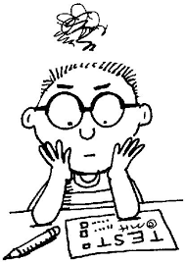
3. Check off the methods you used to prepare for this assessment:
- Read notes
- Re-wrote notes
- Highlighted notes
- Printed out back-up copies and/or answer keys of notes
- Made flashcards (online or hand-written)
- Made a practice quiz or review sheet and took it; checked my answers
- Had someone else quiz me
- Attended extra help
- Asked an adult to look over assignment
- Tried to teach the information to someone else or quizzed someone else
- Made an audio/video recording of myself asking/answering questions or reading notes; listened to it repeatedly
- Other: _________________________________________________________________________________________

(OVER)

Question # answered incorrectly | Question type  MC = multiple choice  MA = matching  C = chart  SA = short answer  P = paragraph  FI = Fill in | Skill being assessed in question:  (write in the skill below)  - recall/memorization  - Inference/applying knowledge (How/why question)  - Making connections between topics/ideas  - Interpreting map/graph  - Forming your own opinion  - comparing/contrasting  - Explaining an idea | Correct answer  (look it up in your notes!) | Reason why you think you made the error  (use one or more codes below)  1 - careless mistake  2 - difficulty remembering info  3 - did not study enough  4 - did not understand what the question was asking  5 - did not understand one or more words in the question  6 - did not read all of the answer choices thoroughly  7 - did not include enough details in my answer

