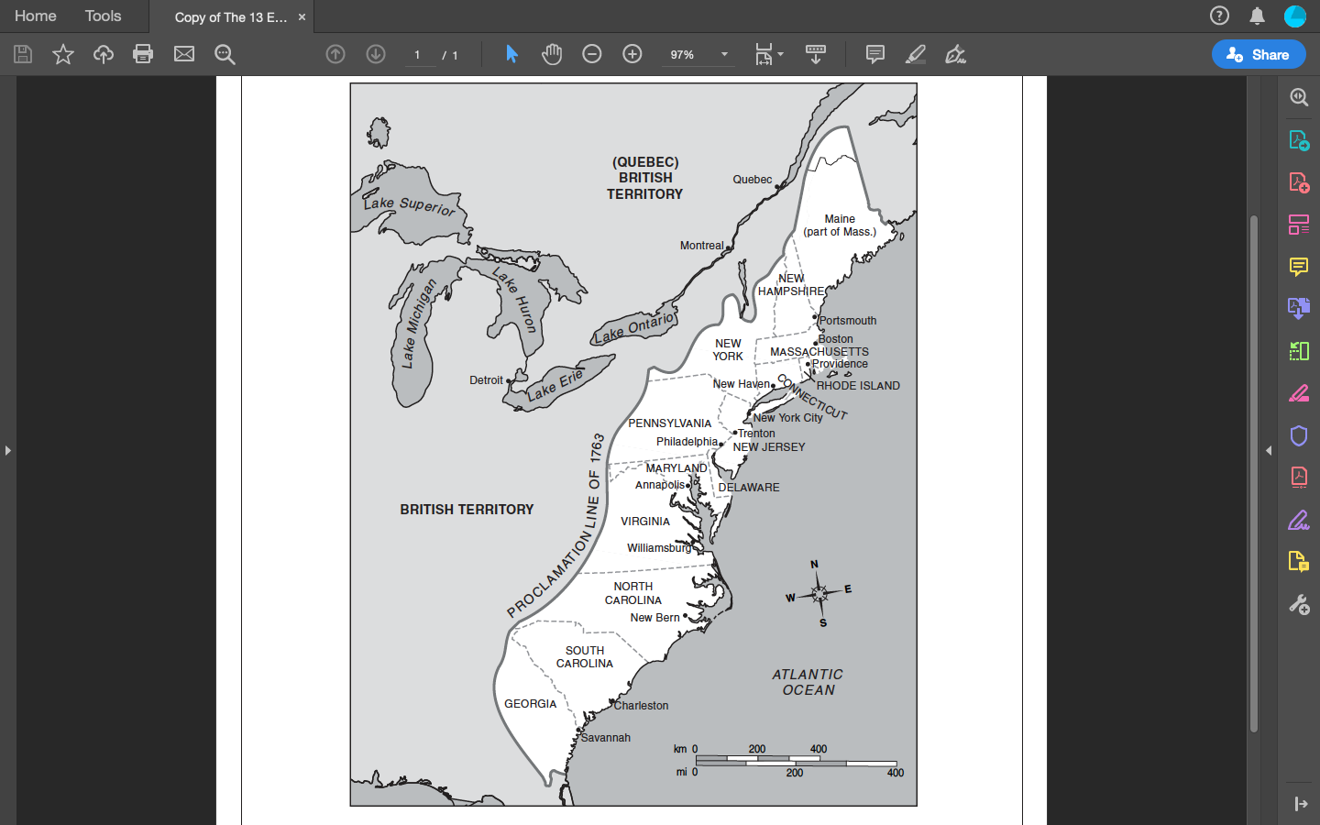

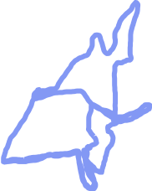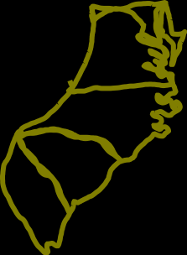

|  |  |  |
| --- | --- | --- |
| **New England Colonies** | **Middle Colonies** | **Southern Colonies** |
| **Massachusetts** | **New York** | **Maryland** |
| **Rhode Island** | **New Jersey** | **Virginia** |
| **Connecticut** | **Pennsylvania** | **North Carolina** |
| **New Hampshire** | **Delaware** | **South Carolina** |
|  |  | **Georgia** |