Name_______________________________________ Date__________
Period_______________ Unit 2 Day 4
Columbus Perspective #1
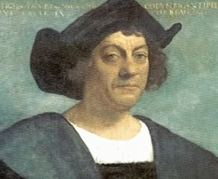
Christopher Columbus opened up a New World to Europeans. As a result, he became a hero to millions who settled in the Americas. Read the excerpt below and answer the questions that follow.
Joel Barlow was an early American poet who lived from 1754 to 1812. The following is an abridged excerpt from his poem The Vision of Columbus which hailed the explorer as a hero.

This extraordinary man, who was now about twenty-seven years of age, appears to have united in his personality every trait, and to have possessed every talent, required to form and achieve the greatest accomplishments. He had had great knowledge in geography, astronomy and drawing, as they were necessary to his favorite pursuit (hobby) of navigation. He had now been a number of years in the service of the Portuguese, and had acquired (learned) all the experience that their voyages and discoveries could afford (give). His courage and perseverance (drive) had been put to the severest (hardest) test, and the exercise (use) of every amiable (good-natured) and heroic virtue made him universally known and respected.

Such was the situation of Columbus, when he formed and thoroughly created a plan, which … unfolded to the view of mankind one half of the globe, diffused (gave) wealth and dignity (self-esteem) over the other, and extended commerce (trade) and civilization through the whole (entire world).
--Joel Barlow, The Vision of Columbus (1787)

- Who is the author of this excerpt? Joel Barlow
- When was this poem written? 1787 (almost 300 years after Columbus’ voyage)
- According to the poem, what are some of Columbus’ characteristics? Highlight them in the passage.
- What do you think is the author’s purpose in this document? (how does he want you to view Columbus?
The purpose of the excerpt is to portray Columbus in a positive light. According to the excerpt he is courageous, smart, determined, and achieved great success at an early age. Because of his achievements, the entire world benefited from commerce, wealth, and knowledge of the world.
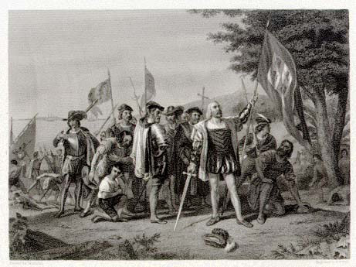
Columbus Perspective #2

Christopher Columbus kept a detailed record of his voyages to the New World. This is an abridged excerpt from his journal on the day he first made contact with natives. Read the excerpt below and answer the questions that follow.
“They brought us parrots and balls of cotton and spears and many other things, which they exchanged for the glass beads and hawks' bells. They willingly traded everything they owned … They do not bear arms (have weapons), and do not know them, for I showed them a sword, they took it by the edge and cut themselves out of ignorance. They have no iron. Their spears are made of sugar cane. They would make fine servants. With 50 men we could subjugate (overpower) them all and make them do whatever we want…

And I believed and believe that people do come here from the mainland to take them as slaves. They ought to be good servants and of good skill, for I believe that they would easily be made Christians, because it seemed to me that they belonged to no religion.

…I was very attentive to them, and strove to learn if they had any gold. Seeing some of them with little bits of this metal hanging at their noses, I gathered from them by signs that by going southward or steering round the island in that direction there would be found a king who possessed large vessels of gold, and in great quantities.”
-- Christopher Columbus, (October 1492)

- Who is the author of this diary entry? Christopher Columbus
- When was this entry written? 1492
- Describe Columbus’ encounter with the Native Americans.
Columbus lands and begins to trade with the Natives. They do not have weapons and sees them as inferior/weak. He suggests making them servants/slaves to do any work Columbus and his crew may choose. He observes they would easily be made Christians, as they had no religion that he could see. He plans to use them to help him find gold.

- What are Columbus’ goals when he encounters the Natives? Highlight them in the passage.

