Name _________________________ Date ___________
Period_____________ Unit 4 Day 5
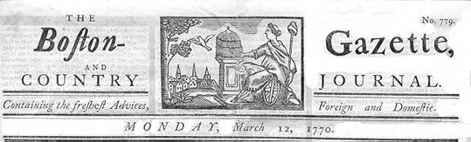

The Boston Gazette

On the evening of Monday, being the fifth current, several soldiers of the 29th Regiment were seen parading the streets with their drawn cutlasses and bayonets, abusing and wounding numbers of the inhabitants.

A few minutes after nine o'clock four youths, named Edward Archibald, William Merchant, Francis Archibald, and John Leech, jun., came down Cornhill together, and separating at Doctor Loring's corner, the two former were passing the narrow alley leading to Murray's barrack in which was a soldier brandishing a broad sword of an uncommon size against the walls, out of which he struck fire plentifully. A person of mean countenance armed with a large cudgel bore him company. Edward Archibald admonished Mr. Merchant to take care of the sword, on which the soldier turned round and struck Archibald on the arm, then pushed at Merchant and pierced through his clothes inside the arm close to the armpit and grazed the skin. Merchant then struck the soldier with a short stick he had; and the other person ran to the barrack and brought with him two soldiers, one armed with a pair of tongs, the other with a shovel. He with the tongs pursued Archbald back through the alley, collared and laid him over the head with the tongs.

Question 1: Who struck first, according to this article? The British Soldiers
Question 2: Are the British soldiers described in an innocent way or in a threatening way? Threatening
Underline words in the paragraph above that help the reader to come to this conclusion.

The noise brought people together; and John Hicks, a young lad, coming up, knocked the soldier down but let him get up again; and more lads gathering, drove them back to the barrack where the boys stood some time as it were to keep them in. In less than a minute ten or twelve of them came out with drawn cutlasses, clubs, and bayonets and set upon the unarmed boys and young folk who stood them a little while but, finding the inequality of their equipment, dispersed.

Question 3: After forcing the soldiers back to their barrack, why did the “lads” run away? They were outnumbered by British soldiers with weapons.

On hearing the noise, one Samuel Atwood came up to see what was the matter; and entering the alley from dock square, heard the latter part of the combat; and when the boys had dispersed he met the ten or twelve soldiers aforesaid rushing down the alley towards the square and asked them if they intended to murder people? They answered Yes, by G-d, root and branch! With that one of them struck Mr. Atwood with a club which was repeated by another; and being unarmed, he turned to go off and received a wound on the left shoulder which reached the bone and gave him much pain. Retreating a few steps, Mr. Atwood met two officers and said, gentlemen, what is the matter? They answered, you'll see by and by.

Question 4: Does this paragraph portray the British soldiers as innocent or guilty? How?
He says the British said they would murder the people.

Thirty or forty persons, mostly lads, being by this means gathered in King Street, Capt. Preston with a party of men with charged bayonets, came from the main guard to the commissioner's house, the soldiers pushing their bayonets, crying, make way! They took place by the custom house and, continuing to push to drive the people off, pricked some in several places, on which they were clamorous and, it is said, threw snow balls. On this, the Captain commanded them to fire; and more snow balls coming, he again said, damn you, fire, be the consequence what it will! One soldier then fired, and a townsman with a cudgel struck him over the hands with such force that he dropped his firelock; and, rushing forward, aimed a blow at the Captain's head which grazed his hat and fell pretty heavy upon his arm. However, the soldiers continued the fire successively till seven or eight or, as some say, eleven guns were discharged.

Question 5: What, according to the author, prompted the British soldier to fire into the crowd?
Colonists throwing snowballs – Captain commanded soldiers to fire.
Questions 6: Does the source of this article have anything to do with how the events were portrayed? How? Yes- article written in Boston, by colonists – it will reflect colonists’ point of view.

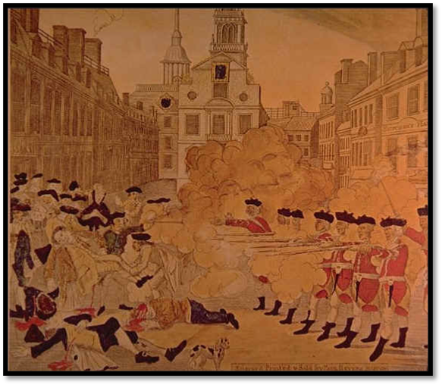



Excerpt of Article from The London Chronicle
April 26–28, 1770

The following is a substance of a letter from Boston, dated the 12th of March, relative to the unhappy affair between the Townsmen and the Soldiers on the 5th of that month:

[Excerpt is part of a letter from British Captain Thomas Preston]
…”In my way there I saw the people in great commotion, and heard them use the most cruel and horrid threats against the troops. In a few minutes after I reached the guard, about a hundred people passed it and went towards the Custom House, where the King’s money is lodged. They immediately surrounded the sentinel posted there, and with clubs and other weapons threatened to execute their vengeance upon him. I was soon informed by a townsman, their intention was to carry off the soldier from his post, and probably murder him. …[An officer]soon came back and assured me he heard the mob declare they would murder him. This I feared might be a prelude to their plundering the King’s chest. I immediately sent a non-commissioned officer and twelve men to protect both the sentinel and the King’s money, and very soon followed myself, to prevent, if possible, all disorder, fearing lest the officer and soldiery by the insults and provocations of the rioters, should be thrown off their guard and commit some rash act.

Question 1: From Captain Preston’s point of view, what was the intent of the crowd?
Captain Preston felt tht the colonists intended to murder the soldier and steal the King’s money.

They soon rushed through the people, and, by charging their bayonets in half circle, kept them at a little distance. … The mob still increased, and were more outrageous, striking their clubs or bludgeons, one against the other and calling out, ‘Come on you rascals, you bloody backs, you lobster scoundrels; fire if you dare, G__damn you fire, and be damned, we know you dare not;’ and much more such language was used. At this time I was between the soldiers and the mob, parleying with and endeavoring all in my power to persuade them to retire peaceably; but to no purpose. They advanced up to the points of the bayonets, struck some of them, and even the muzzles of the pieces and seemed to be endeavoring too close with the soldiers.

Question 2: Describe how, according to Captain Preston, the colonists taunted the British.
The colonists struck their clubs together and called out, “Come on you rascals, you bloody backs, you lobster scoundrels, fire if you dare.” They insulted and dared the soldiers to fire into the crowd. They walked up to the British, even hitting their guns.

On which some well behaved persons asked me if the guns were charged. I replied; yes. They even asked me if I intended to order the men to fire; I answered, no, by no means…While I was thus speaking, one of the soldiers, having received a severe blow with a stick, stepped a little on one side and instantly fired; on which turning to and asking him why he fired with orders, I was struck with a club on my arm, which for some time deprived me of the use of it; which blow, had it been placed on my head, most probably would have destroyed me. On this a general attack was made on the men by a great number of heavy clubs and snow-balls being thrown at them, by which all our lives were in imminent danger; some persons at the same time from behind calling out; ‘Damn your bloods, why don’t you fire?’ Instantly three or four of the soldiers fired, one after another, and directly after, three more in the same confusion and hurry.

Question 3: Which side appears to be at blame for the soldiers firing their guns? Why?
The colonists because they hit the soldiers and they fired on accident.

The mob then ran away, except three unhappy men who instantly expired, in which number was Mr. Gray, at whose ropewalk the prior quarrel took place; one more is since dead; three others are dangerously and four frightfully wounded. The whole of this melancholy affair was transacted in almost 20 minutes. On my asking the soldiers why they fired without orders, they said they heard the word, “Fire,” and supposed it came from me. This might be the case, as many of the mob called out; ‘fire, fire,’ but I assured the men that I gave no such order, that my words were; ‘Don’t fire, stop your firing!’ in short it was scare possible for the soldiers to know who said fire, or don’t fire, or stop your firing.

Question 4: How does Captain Preston portray this event as possibly accidental?
Preston says the soldiers thought he said “fire” when the mob were really the ones that said “fire.”
Question 5: Would Captain Preston have any reason not to tell the exact truth? Explain.
Yes → he won’t be at fault, the soldiers won’t be in trouble.
No → He is being honest in court, he is telling his point of view.



