Part 1: Recap of the Monroe Doctrine

Directions: Below you will find a political cartoon that shows the Monroe Doctrine. Answer the questions that follow. Listen to the audio/slideshow HERE to review what the Monroe Doctrine was about!
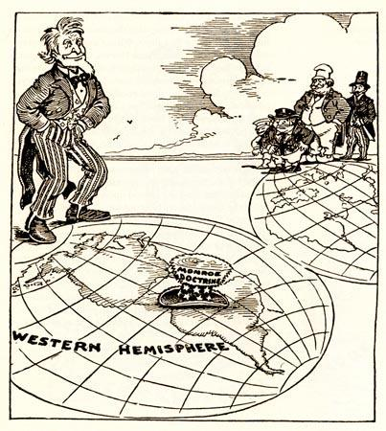
- Who is the man in the left corner AND who does he represent?
  - Uncle Sam and he represents the United States.
- How can you tell who this man is?
  - Uncle Sam wears stars and stripes to represent the United States.
- What part of the world is his hat on?
  - South America (Latin America)
- Why is his hat placed on this area?
  - Uncle Sam’s hat is placed there because the Monroe Doctrine protects Latin America from European influence.

Part 2: Sectionalism in the Era of Good Feelings

Directions: Answer questions #1-4 below the reading and the cartoon, in COMPLETE SENTENCES!

As nationalism, or pride or devotion to one’s country, grew in the United States, sectionalism also grew. We use the word “sectionalism” to describe the conflict between geographic sections of the nation. Sectionalism can be defined as the loyalty to the interests or needs of one’s own state or region OVER the interest of the whole country. For example, Ms. Meritz only cares if she has enough coffee while in quarantine and not if the entire house has coffee (It is in everyone’s best interest if Ms. Meritz has coffee, otherwise, she is cranky and mean to everyone else, 1st period, you know this to be true).
During the early 1800s in the United States, the Northeast focused on factories and trade, the South relied on plantations and cash crops, and now the West was a place for people to exploit (use) new land. This created regional politics because their economies were based on different things in order to be successful. The North wanted high tariffs, or taxes on foreign goods, so that people would buy American-made goods. The South supported slavery, and they also supported low tariffs, because they imported most of their goods from foreign countries. Westerners wanted the government to sell its land at a high price and give them roads and other public improvements.

- Define and describe “sectionalism.”
  - Sectionalism can be defined as the conflict between geographic sections of the nation. It means that you have loyalty to the interests or needs of your own state or region over the interests of the whole country.
- Describe the economies (how people made money) for each region of the U.S.:
  - North: Factories and trade.
  - South: Plantations and cash crops.
  - West: Use the new land for farming.
- Why was there an increase in sectionalism at the end of the Era of Good Feelings?
  - There was an increase in sectionalism because regional politics led to each region wanting taxes and tariffs that helped their economy, even if it hurt the other regions.
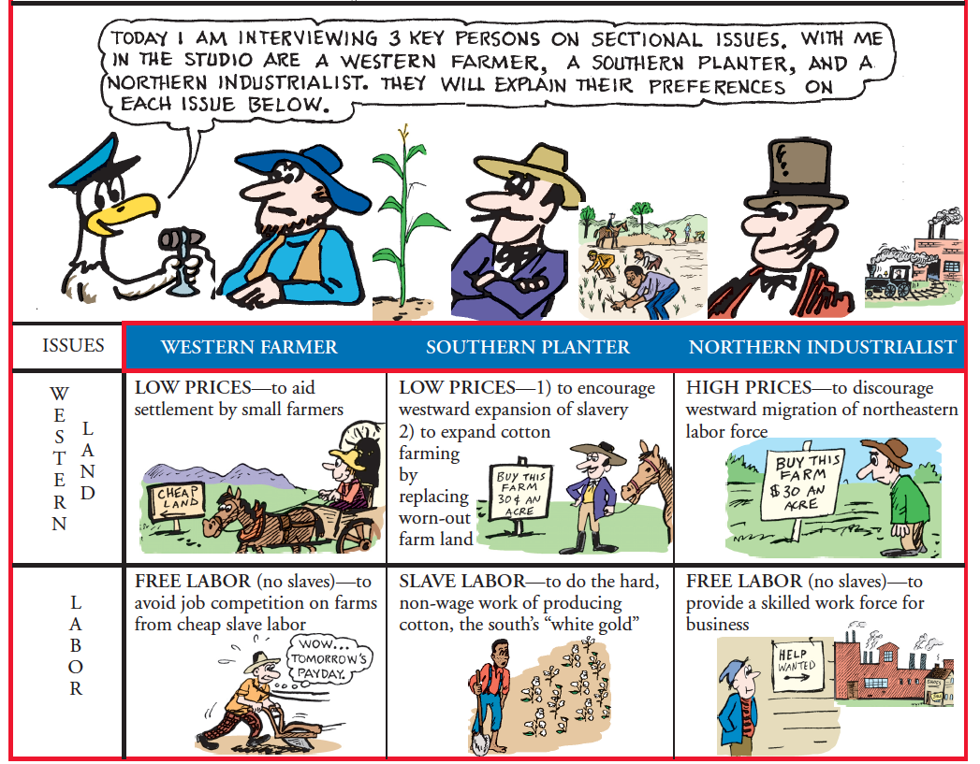
4. According to the cartoon, what do you think the next big issue will be that will divide the nation, and why?
Answers will vary. Should be about western lands or labor.

Part 3: The Missouri Compromise

Directions: Answer questions #1-4 below the reading in COMPLETE SENTENCES!

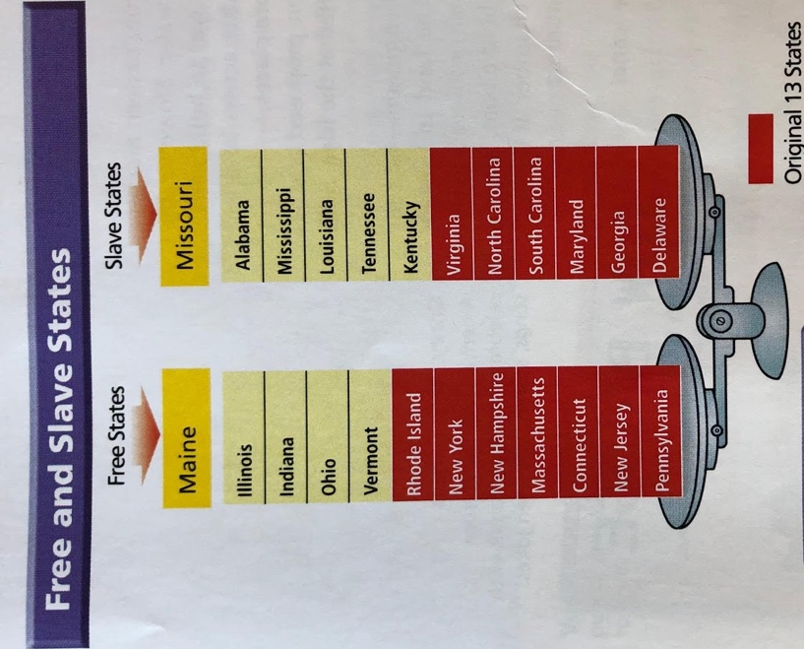
A conflict rooted in sectionalism happened when Missouri applied for statehood in 1817. At the time, the U.S. consisted of 11 slave states and 11 free states (no slavery allowed). If Missouri entered the Union (United States) as a slave state, as it wanted, it would upset a balance of power in the Senate between slave and free states. This could mean that Congress could pass laws that benefit slave states, and not free states, because there were more Senators and Representatives that would support slavery. We call the United States “the Union” during this time because the states saw themselves as a group of individual states that agreed to come together (unite) as one country, but now sectionalism is slowly becoming a problem.
In 1820, Henry Clay (remember? War Hawk from the west) came up with a solution for the land from the Louisiana Purchase. This solution was called the Missouri Compromise. The Missouri Compromise has two parts: One; Missouri would enter the Union as a slave state, but Maine, which was still a part of Massachusetts, would enter at the same time as a free state. Two; For all future applications for statehood, slavery would be illegal north of the Southern border of Missouri. Any new state created below the southern border of Missouri would be a slave state.
The Missouri Compromise divided land from the Louisiana Purchase into separate regions defined by slavery. Slavery was increasingly becoming an issue that divided the North and South. The Missouri Compromise revealed how much sectional rivalries divided the states of the Union. The compromise seemed to balance the interests of the North and the South. However, white southerners were not happy that Congress had given itself the power to make laws regarding slavery. Many northerners, in turn, were angry that Congress had allowed slavery to expand into another state.
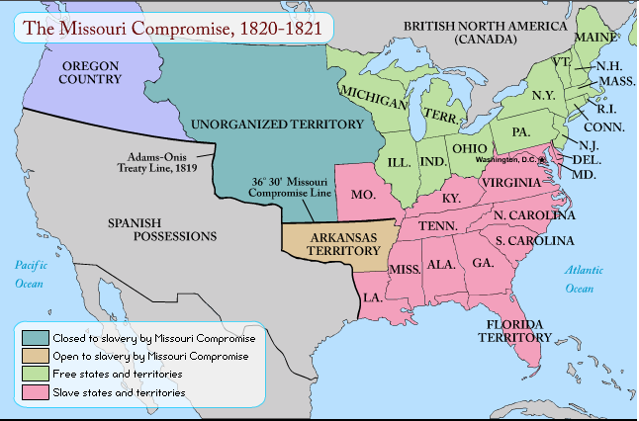
Under the Adams-Onis Treaty of 1819, Spain gave up Florida to the United States because they realized they could no longer protect that colony after losing control of so many colonies in South America.

- What issue did the Missouri Compromise aim to settle?
  - The balance of slave states and free states in the US.
- According to the chart, which of the following was a free state: Kentucky, Tennessee, or Ohio?
  - Ohio
- What were the two parts of the Missouri Compromise?
  - Missouri would enter as a slave state, Maine would enter the Union as a free state.
  - For all future applications for statehood, slavery would be illegal north of the Southern border of Missouri. Any new state created below the southern border of Missouri would be a slave state.
- CRITICAL THINKING: Why would the issues addressed by the Missouri Compromise continue to tear the nation apart?
  - As the US gained more land, more states would be created. This will upset the balance that the Missouri Compromise created.
Watch this video when you are done to give you a recap of the Monroe Presidency and these issues. Click Here!

