DIRECTIONS: Read the passages below and answer the questions as you read. You can type your answers next to the bullet symbols. Each section will have words that are highlighted and underlined in blue. This means that there is a link that will take you to a video to help you understand the topic. WE HIGHLY SUGGEST you watch the videos at some point in time.

A Revolution in Technology
In the 1700s, a great change began that we now call the Industrial Revolution. Gradually, machines took the place of many hand tools. Much of the power once provided by people and horses began to be replaced, first by flowing water and then by steam engines.

Steam Power
Building factories on riverbanks had some disadvantages. In a dry season, the machines had no power. Also, most factories were far from cities, and labor was hard to find in rural areas. In 1790, Richard Arkwright built the first steam-powered textile plant. The steam engine was a reliable source of power. Factories no longer had to be built on riverbanks. They could be built in cities, where young women and children provided cheap labor.

1A. Describe two reasons why building factories on riverbanks had some disadvantages.
- In a dry season, the machine had no power and most factories were far from cities, which made labor hard to find.
Interchangeable Parts
One of the most important developments of the industrial revolution was mass production, or the rapid manufacture of large numbers of identical objects. Before the 1800s, skilled craftworkers manufactured clocks, guns, and other mechanical products. Each part of the gun or clock was handcrafted. When a part broke, a craftsworker had to create a unique piece to fit the product. In the 1790s, American inventor Eli Whitney created a system of interchangeable parts, identical pieces that could be assembled quickly by unskilled workers.
Interchangeable parts soon came to be used in the manufacture of other products. Manufacturing became more efficient. The price of many goods dropped. As people bought more goods, U.S. industry expanded to satisfy their needs.

2A. Define “interchangeable parts.”
- Interchangeable parts are identical pieces that could be assembled quickly by unskilled workers.
3A.. How did Eli Ehitney’s system of interchangeable parts speed up the manufacturing process?
- Interchangeable parts made manufacturing faster and more efficient. This led to more products being made at lower prices.

The Growth of a Nation: Communication, Transportation, & Agricultural Technology
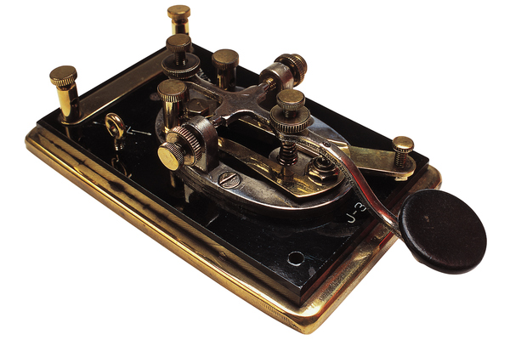
Communication: The Telegraph
New inventions revolutionized communications. The most important was the telegraph, a device that used electrical signals to send messages quickly over long distances. Samuel Morse’s invention worked by sending electrical signals over a wire. A code devised by Morse used shorter and longer bursts of electricity. In his system, known as Morse code, each letter of the alphabet is represented by its own mix of short signals (“dots”) and long signals (“dashes”). The first successful message went from Washington, D.C. to Baltimore in 1844. The message was, “What hath God wrought?”
The telegraph soon became part of American life. Thousands of miles of wires were strung across the nation. Factories in the East could communicate with their markets in the West in a matter of hours rather than weeks.

1B. Define “telegraph.”
- A device that used electrical signals to send messages quickly over long distances by sending electrical signals over a wire.

Transportation: Steamboats, Railroads, Turnpikes, and Canals

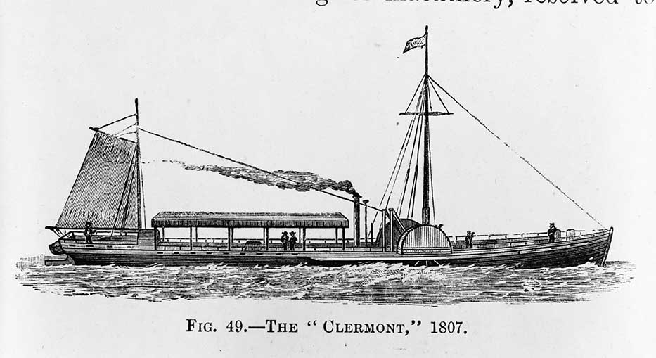
Steamboats
Improvements in transportation spurred the growth of American industry. As transportation became faster and easier, factories could make use of raw materials from farther away. Improved transportation also allowed factory owners to ship their goods to distant markets.
In 1807, Robert Fulton, an American inventor, used a steam engine to power a boat. Fulton’s Clermont was the first practical steamboat. It was 133 feet long and had wooden side paddles that pulled through the water. Although side-paddle steamboats were ideal for traveling on rivers, they were not suited to ocean travel.
In 1850, a new type of American-built ship appeared, the clipper ship. Long and slender, with tall masts, the clipper ships were fast vessels. The Yankee clippers, as they were called, were the fastest ships. By the late 1850s, however, Great Britain was producing ocean going steamships. These ironclad steamships were faster and could carry more cargo

2B. Who created the first steamboat and what was the boat's name?
- Robert Fulton and it was called the Clermont.
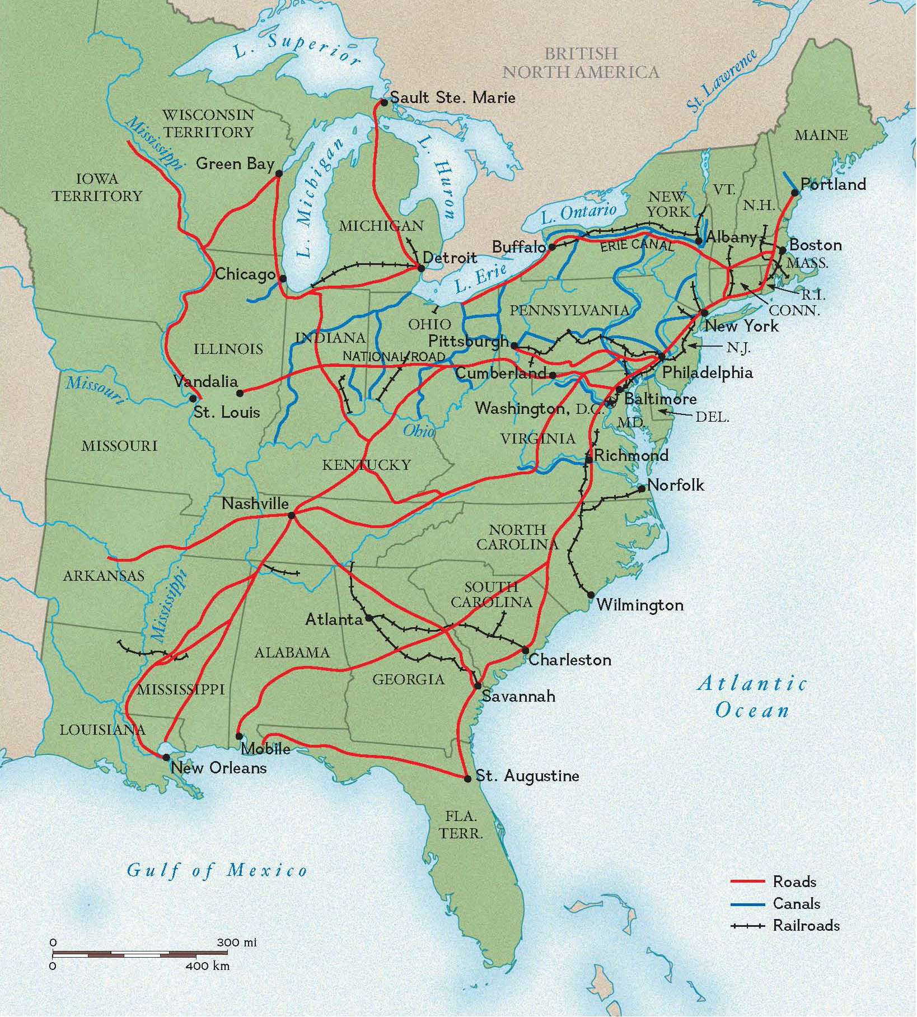
Railroads
Of all forms of transportation, railroads did the most to tie together raw materials, manufacturers, and markets. Steamboats had to follow the paths of rivers, which sometimes froze in winter. Railroads, however, could be built almost anywhere.
America’s first railroad, the Baltimore and Ohio, started in 1828. As with most European railroads, its cars were drawn along the track by horses. Then, in 1830, Peter Cooper built the first American-made steam locomotive. By 1840, about 3,000 miles of railway track had been built in the United States.

3B. Why were railroads a better means of transportation than steamboats?
- Railroads could be built anywhere but steamboats had to follow the paths of rivers which often froze in the winter.

Roads and Turnpikes
By the early 1800s, the flow of people to the West had become a flood. As western populations grew, many areas applied to become states. From 1792 to 1819, eight states joined the Union: Kentucky (1792), Tennessee (1796), Ohio (1803), Louisiana (1812), Indiana (1816), Mississippi (1817), Illinois (1818), and Alabama (1819). Traveling west was not easy, as many early roads were unpaved, dotted with tree stumps, and easily washed out by rain.
Clearly the nation needed better roads. Farmers and merchants had to have a way to move their goods to market quickly and cheaply. Private companies began to build turnpikes, or toll roads. At certain points, a bar on a hinge swung out across the road. The bar resembled a spear, or a pike. Travelers would have to stop and pay a toll in order to pass. The first long-distance stone road turnpike was built between Lancaster and Philadelphia, Pennsylvania in 1795. The road provided cheap, reliable transportation to isolated agricultural areas.
4B. Describe how roads improved over time as more and more people moved west.
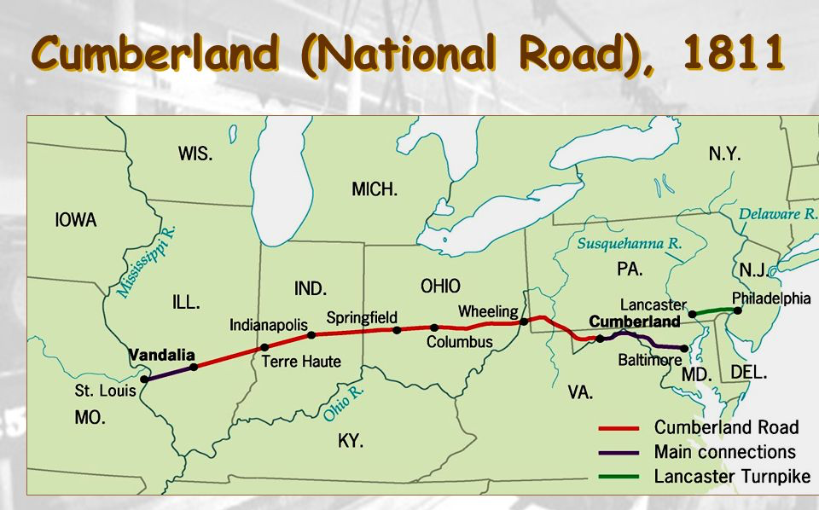
- Early roads were unpaved, dotted with tree stumps and washed out by rain. Private companies then built turnpikes that provided cheap, reliable transportation to isolated agricultural areas.

In marshy areas, wagons traveled on corduroy roads, roads made of sawed-off logs, laid side by side. This meant a bumpy ride as the wagon bounced over each log. Corduroy roads were a hazard to horses, because they could break their legs if they slipped through the logs.
The National Road was the first federally funded road. Started in 1811 in Cumberland, Maryland, it stretched to Wheeling, in western Virginia, by 1818 and reached Vandalia, Illinois in 1850. The road crossed hundreds of miles of varying terrain. Bridges carried it over many rivers and streams.
5B. Define “corduroy roads.”
- Roads made of sawed-off logs, laid sided by side which created a bumpy ride that was often hazardous to horses.
Canals
Slow road travel isolated western farmers from eastern markets. The fastest, cheapest way to ship goods was by water. However, the major rivers ran north and south. The solution was to build canals from east to west. A canal is a channel that is dug across land and filled with water. Canals allow boats to reach more places.
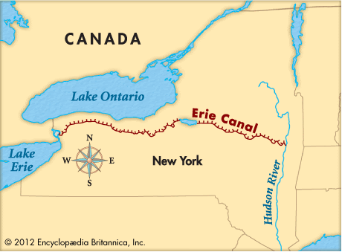
In 1816, New York Governor DeWitt Clinton proposed a canal from the Hudson River to Lake Erie. Building the canal was a challenge for canal engineers - and for workers, who were mostly Irish immigrants. The land in upstate New York is not level. Locks had to be built to raise or lower boats in the canal. Locks are chambers just big enough to hold a boat. When a boat enters a lock, gates close at both ends of the chamber. If the boat is to be raised, water flows into the lock. If the boat must be lowered, water drains out.
Within two years of its opening in 1825, the canal had paid for itself. Produce from the Midwest came across Lake Erie, passed through the Erie Canal, and was carried down the Hudson River to New York City. Because of its location at the end of the river, New York soon became the richest city in the nation.

6B. Why were most canals built east to west?
- Most canals were built east to west because major rivers ran north to south.
7B. How did the Erie Canal benefit New York City?
- New York became the richest city in the nation because of the Erie Canal.

Agriculture: The Reaper, Sewing Machine, and Cotton Gin
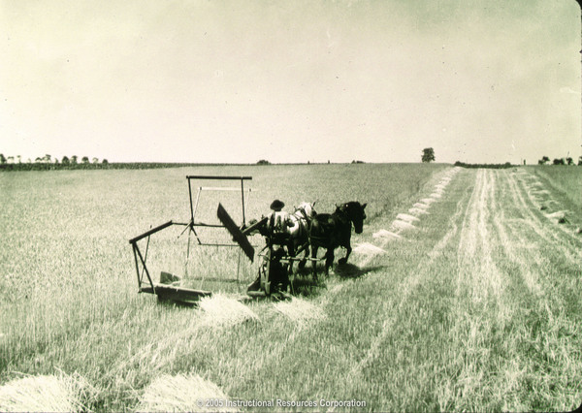
The Reaper
The mechanical reaper, invented by Cyrus McCormick, made it easier for farmers to settle the prairies of the Midwest. The reaper cut stalks of wheat many times faster than a human worker could. This enabled farmers to cultivate more land and harvest their crops with fewer workers.
Improvements in threshers also speeded up the harvesting of grain. Threshers separate the grains of wheat from their stalks. The wheat grains are then ground into flour. Eventually, the mechanical reaper and the thresher were put together into one machine called a combine.
These advances in agriculture also affected industry. Farm laborers who had been replaced by machines went to cities to work in shops and factories. Cities like Cincinnati grew as both agricultural and industrial centers.

8B. Describe the positive impact of the mechanical reaper and thresher on the agricultural (farming) industry.
- The mechanical reaper and thresher made it easier for farmers to settle in the Midwest and cultivate land and harvest their crops faster and with fewer workers.

The Sewing Machine
Other inventions revolutionized the way goods were made. In 1846, Elias Howe patented a machine that could sew seams in fabric. A few years later, Isaac Singer improved on Howe’s design. The sewing machine made it much more efficient to produce clothing in quantity. As clothes became less expensive, people of modest means (didn’t have much money) began to dress almost as well as wealthier Americans. By 1860, factories in New England and the Middle Atlantic states were producing most of the nation's manufactured goods. That year, Americans had over $1 billion invested in businesses. Of that total, more than 90 percent were invested in business in the North.

9B. How did the sewing machine help northern industry to grow?
- Clothes became less expensive, people began to buy more clothes and were better dressed, and New England and the Middle Atlantic states were producing most of the nation’s manufactured goods.

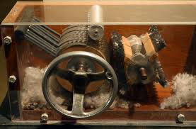
The Cotton Gin
As the North became more urban and industrialized, the South remained largely rural and agricultural. Two events changed life in the South. First, a boom in textiles caused by the Industrial Revolution created a huge demand for cotton. Second, a new invention allowed the South to satisfy that demand.
In 1793, Eli Whitney devised a simple machine that sped up the processing of cotton. His cotton gin used a spiked cylinder to remove seeds from cotton fibers. Before the introduction of the cotton gin, the seeds had to be picked out of the cotton fibers by hand. This was a slow process. Working by hand, a laborer could clean only a pound of cotton a day.
The cotton gin was a revolutionary technology. A worker could process fifty times more cotton fiber with the gin than by hand. Cotton growing became far more profitable. Because cotton growing led to more money, cotton planters used more slave labor.
In the southern “Cotton Kingdom,” society was dominated by owners of large plantations. This small but wealthy class lived in luxury and sent their children to the finest schools. But more than half of all southern farmers did not have slaves. They grew corn and raised hogs and chickens.

10B. Why was there an increased demand for cotton?
- A boom in textiles caused by the Industrial Revolution created a huge demand for cotton and the cotton gin was able to satisfy that demand.
11B. How did the cotton gin make growing cotton more profitable (helped farmers make more money)?
- The cotton gin made growing cotton more profitable because a worker could now process fifty times more cotton fiber with the gin than by hand. This led to cotton platers using more slave labor to make more money.

Here’s a video that covers most of what we have learned so far for the Industrial Revolution. Click Here!
