DIRECTIONS: Read the passages below and answer the questions as you read. You can type your answers next to the bullet symbols. After each passage (the orange titles, there are two in total) there will be a video to help you understand what you just read. If you would like, watch the video first!

The Industrial Revolution Begins
In the 1700s, most people in the United States were farmers. Almost all goods were made by hand, either in homes or in small shops. However, toward the end of the century, people in Great Britain began inventing machines. These new machines made more goods faster and more efficiently.
- How did most people make a living (earn money)in the 1700s?
- Most people were farmers or made goods by hand.
The change from hand production to machine production and the development of factories that paid workers daily were both part of the movement known as the Industrial Revolution. In a relatively short time, people’s home and work lives completely changed because of new inventions and ways of working. The Industrial Revolution spurred another economic development, the market revolution. Instead of producing their own food and clothing, for example, more individuals and families began purchasing mass-produced items in the marketplace. This meant a large amount of the same, identical items were being purchased. There were less personalized, homemade items being bought.
The first industry to use machines was the textile, or cloth, industry. In the 1700s, the first textile factories were started in Great Britain. The British automated production, or used machines instead of people to spin thread and weave cloth. That way, the factories were able to produce huge amounts of cloth quickly and cheaply. These early factories needed water power to run the machines. Most factories were built along rivers.
- What was the first industry of the Industrial Revolution?
- The first industry was the textile, or cloth, industry.
- What does the phrase automated production mean, according to the reading? (Don’t Google!)
- Automated production means using machines instead of people to make goods.
- Where did the Industrial Revolution begin?
- The Industrial Revolution began in Great Britain.
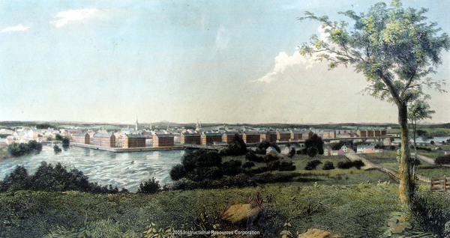
Watch the video to learn more: New Machines: The Births of an Industrial Revolution

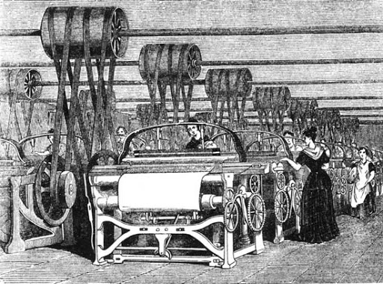
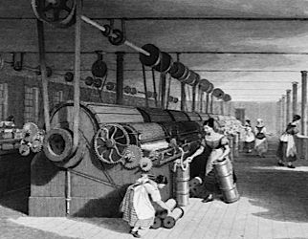

The Industrial Revolution Comes to New England

In 1789, a British mechanic named Samuel Slater secretly went to the United States. Slater had memorized the plans for textile plant machinery. He was able to make copies. In 1793, in Pawtucket, Rhode Island, Slater and others built the first cotton-spinning mill in the United States. Within about 15 years, Slater helped run 12 different mills in New England.
- Who made the first cotton-spinning mill in the United States?
- Samuel Slater made the first cotton-spinning mill.
- What state was the first to have a cotton-spinning mill in the United States?
- Rhode Island was the first to have a cotton-spinning mill in the US.
The textile industry went through a series of major changes. First, came machines that could spin cotton into yarn. Soon after, people developed power looms, which wove yarn into cloth. A wealthy businessman named Francis Cabot Lowell built the first factory that joined these different aspects of textiles. He built many factories in what would become Lowell, Massachusetts. Lowell’s factories were built along the Merrimack River because they used water power to run the machines.
- What did the power loom do?
- The power loom wove yarn into cloth.
- Who built the first textile factory and in what city and state was it located?
- Francis Cabot Lowell build the first textile factory in Lowell, Massachusetts.
- Why was the factory built on the Merrimack River?
- The factory was built on the Merrimack River because they used water power to run the machines.
At first, the workers in the Lowell mills were mostly girls from nearby farms. They wanted to earn money and live on their own. With the country’s growing population, there were not many opportunities for farm wives in the East. At that time, women were not expected to go to college or have careers.
- Describe three reasons why the workers in the Lowell mills were mostly girls.
- Girls were mostly workers in the Lowell mills because they wanted to earn money, live on their own, there weren’t many oportunites for women, and they were not expected to go to college or have careers.
While New England’s land was not ideal for farming, it had many rivers to provide the water power the early mills needed. These factories went on to manufacture (make) goods other than textiles, including power looms and locomotives, which were shipped to other regions and European countries.
The region’s economy grew throughout the 1800s as New England became the center of trading between the southern states and Europe. Many towns and states helped support this economic growth and created more jobs for the people with construction projects for new roads, bridges, and other transportation routes for the manufactured goods. A growing banking industry in New England provided loans to start and grow businesses. In addition, the labor force grew greatly as more and more people moved to towns to work for wages (money) in factories, rather than working on farms or in small shops where they had made goods by hand.
- Why was New England ideal (a good place) for the early mills?
- New England was ideal for the early mills because they had many rivers to power the mills.
- Describe how the textile mills led to the creation of more jobs in New England.
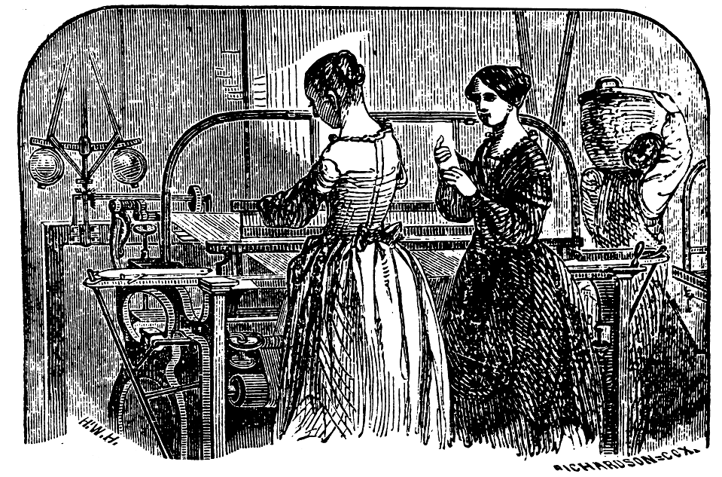
- Towns and states supported economic growth by creating jobs like construction projects for new roads, bridges, and other transportation routes. Banks even provided loans to start and grow new businesses.
However, working conditions in the mills were very bad. The fast machinery made work dangerous. The noise the machines made was loud. The air was filled with dust. Windows were kept closed during the summer. People worked long hours—73 hours per week was standard—but were paid little. Workers often protested working conditions. Over time, immigrants from Europe replaced women workers.
- Describe the negative working conditions in the mills. (include at least 3 reasons).
- The working conditions in the mills were very dangers because the machines were very loud, the air was filled with dust, the windows were kept closed, and people worked long hours and were paid very little.
Watch the video on the Lowell Mills Girls here: Lowell Mill Girls

