Andrew Jackson Reading Comprehension

DIRECTIONS: Below you will find the images from the previous assignment with short reading passages. After you read each passage, answer the questions that follow in the boxes. (This time, we embedded the links you need for the charts/classmates’ responses into this assignment, instead of a separate slideshow.)

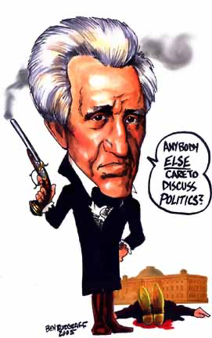
Andrew Jackson: Sectionalism Rears its Ugly Head
Before Jackson took office, Congress raised a tariff, or tax on foreign goods, on raw materials and manufactured goods. The goal of the Tariff of 1828 was to protect the northern United States from competing European goods by causing the prices of those goods to rise. John C. Calhoun, Jackson’s vice president, and Southerners were very much against the tariff. The tariff made Southerners pay more for manufactured goods and they felt the federal government was forcing them to obey an unfair law. They hated it so much that they called in the Tariff of Abominations.
Southerners felt the tariff was unconstitutional because it favored one region over another. South Carolina, with the support of Calhoun, refused to follow the tariff and argued that the states could nullify, or cancel, the tariff. This Nullification Crisis led to South Carolina threatening to secede, or leave the Union, if the federal government used force against the state to make them pay the tariff.
In December of 1832, a furious Jackson put federal troops in South Carolina to be on alert. If South Carolina tried to “dissolve the Union” it would be considered treason. Because of this John C. Calhoun resigned as vice president of the United States. With the federal and state governments arguing over the tariff, by March 1833, Jackson asked Congress to allow the federal government to collect the tariff in South Carolina by force if necessary. As Speaker of the House of Representatives, Henry Clay came up with a plan that would gradually reduce the tariff in order to avoid any violence between the federal and state governments. South Carolina agreed to the compromise and repealed its tariff nullification (took back the cancelation of the tariff).

- 11. Look at the Google Form responses from you and your classmates (CLICK HERE). After reading through the responses, choose one response from you/your classmates which best represents Andrew Jackson after reading the above passage. Re-type it below:
Answers will vary.

- 12. Look at the Google Form responses (CLICK HERE). Did the majority (more) of Team Fire students feel this is a positive portrayal of Jackson, or negative?
Answers will vary.

- 13. Explain why the Southern states disagreed 👎 with the Tariff of 1828.
Southern states disagreed with the Tariff of 1828 became it made Southerners pay more for manufactured goods. They felt the federal government was forcing them to obey an unfair law and viewed the tariff as unconstitutional because if favored one region over another.

- 14. How did the Nullification Crisis show that sectionalism was starting to divide the country?
The Nullification Crisis showed that sectionalism was starting to divide the country because South Carolina threatened to secede, or leave the Union, over the tariff. Because the North and South disagree on the issue, it showed that they were willing to fight over their differences.

(MORE ON NEXT PAGE)
👇

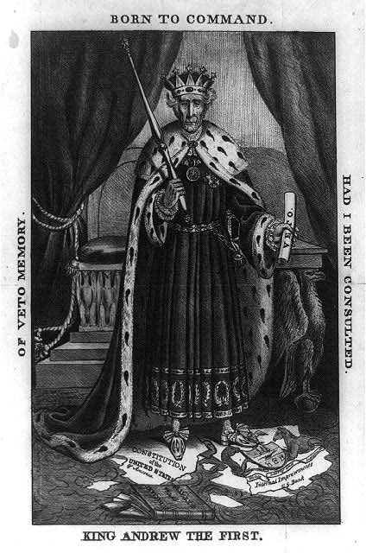
Andrew Jackson: The Man that Would be King
In 1836, the charter, or contract, of the second Bank of the United States was about to run out. To keep the bank going, Congress would need to pass a law extending the charter. Jackson would have to sign it. However, many American disliked the Bank.
The Bank’s most powerful enemy was Andrew Jackson, who called the Bank “the Monster.” According to Jackson, the Bank allowed a small group of the wealthy people to make even more money at the expense, or harm, of ordinary people. Jackson and his supporters felt the Bank of the United States gave special privileges to the wealthy.
The Bank’s new charter was passed by Congress in July of 1832, but, as President, Jackson used his veto power to block the bill. The House of Representatives tried to override, or cancel, the veto, but the bill did not receive the needed two-third of the votes in the Senate. Jackson had succeeded in stopping the reformation of the Bank of the United States.
In order to officially destroy the Bank, Jackson ordered Secretary of the Treasury Roger Taney (a supporter of Jackson that benefited from the Spoils System) to move federal money to private banks. These private banks became known as “pet banks.” Without any federal money, the second Bank of the United States was completely destroyed by 1841.

- 15. Look at the Google Form responses from you and your classmates (CLICK HERE). After reading through the responses, choose one response from you/your classmates which best represents Andrew Jackson after reading the above passage. Re-type it below:
Answers will vary.

- 16. Look at the Google Form responses (CLICK HERE). Did the majority (more) of Team Fire students feel this is a positive portrayal of Jackson, or negative?
Answers will vary.

- 17. Why did Andrew Jackson dislike 👎 the Bank of the United States?
Andrew Jackson disliked the Bank of the United States because he felt the Bank allowed a small group of the wealthy people to make even more money at the expense of the common people. He also felt the Bank gave the wealthy special privileges.

- 18. What is a pet bank, and why were they created?
Pet banks are private banks that were created by Jackson to take money from the Bank of the US. Without federal money, the second Bank of the United States was completely destroyed.

