Andrew Jackson Reading Comprehension

DIRECTIONS: Below you will find the images from the previous assignment with short reading passages. After you read each passage, answer the questions that follow. Type your answers IN THE BOXES below the questions.
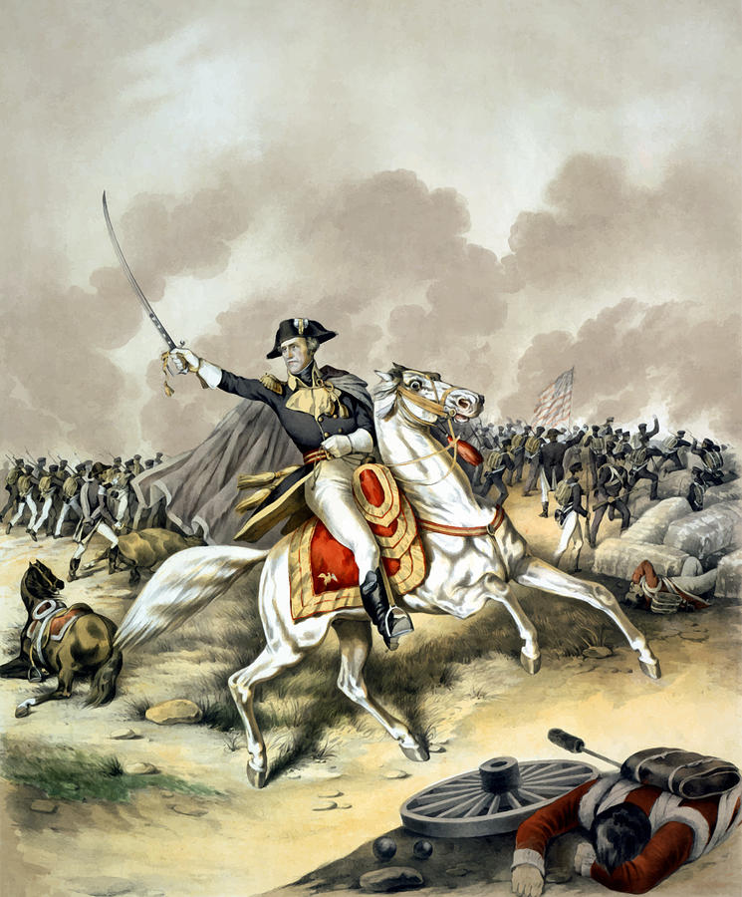
Andrew “Old Hickory” Jackson: War Hero
Andrew Jackson served two terms as President from 1829 to 1837. Andrew Jackson was a wealthy man by the time he became President. However, he began life with very little. Born in a log cabin on the border of North and South Carolina, he was an orphan by the age of 14. Jackson was ambitious, brave, and tough. He survived smallpox as a child and severe gunshot wounds as an adult.
During a difficult march with his troops in 1812, one soldier described him as “tough as hickory.” Hickory trees are extremely strong, and their wood is very tough. The description fit Jackson so well it stuck as a nickname. Jackson became known as Old Hickory. Jackson became a very well known figure in the US after the victory at the Battle of New Orleans during the War of 1812.

- 1. Look at the Google Form responses from you and your classmates. After reading through the responses, choose one response from you/your classmates which best represents Andrew Jackson after reading the above passage. Re-type it below:
Answers will vary

- 2. Look at the Google Form responses. Did the majority (more) of Team Fire students feel this is a positive portrayal of Jackson, or negative?
Answers will vary

- 3. Describe how Andrew Jackson earned the nickname “Old Hickory.”
Andrew Jackson earned the nickname “Old Hickory” when a soldier in 1812 described him as being “tough as hickory.” Hickory trees and extremely strong and very tough, just like Andrew Jackson.
Andrew Jackson: A Man for the People
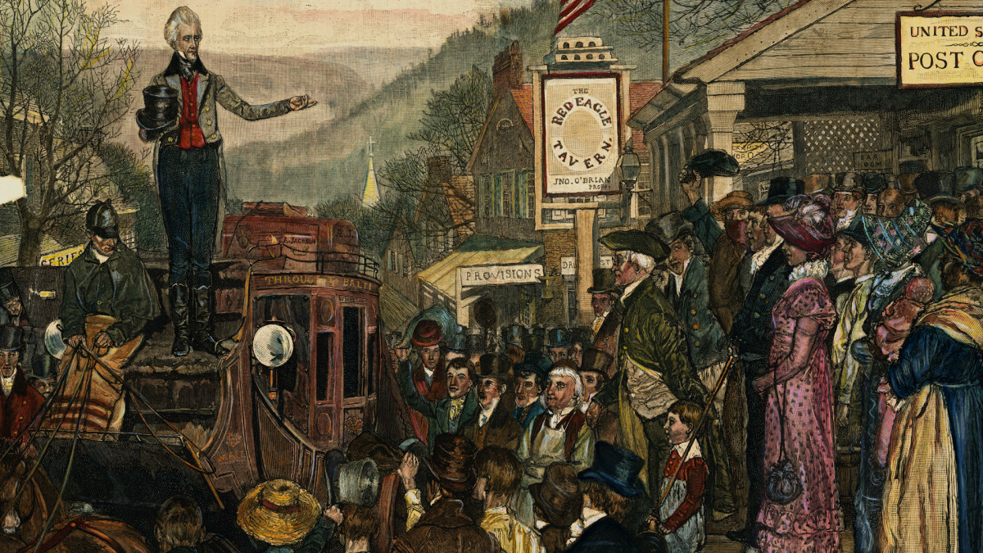
During the election of 1824, there were a number of presidential candidates favored by different regions of the country. The North was in favor of John Quincy Adams, the South supported Andrew Jackson or William Crawford, and the West wanted Henry Clay or Andrew Jackson. Andrew Jackson won the popular vote but did not receive a majority of electoral votes. As a result, the House of Representatives would decide the winner in that situation. After some possible “shady, backroom deals,” John Quincy Adams became the President, even though Andrew Jackson was more well liked by the American people.
The bitterness and anger over the 1824 election led to the development of two new political parties: The Democrats supported Jackson and the National Republicans supported Adams. Jackson was a hardworking national war hero and he won an overwhelming victory. Andrew Jackson became the 7th President of the United States and John C. Calhoun became his vice president.
One reason for Jackson’s victory was that he promoted expanding democratic privileges to a wider population. Called Jacksonian Democracy, this movement included the extension of suffrage. Suffrage is the right to vote. Before, only white men who owned property or paid taxes could vote, but Jackson loosened these restrictions to include more white men - free blacks and women still couldn’t vote. Jackosn’s win was considered a triumph for the common man. Jackson and his supporters did not trust the government. They believed it often favored the rich and powerful. The Jacksonians also were suspicious of banks, which they believed favored the rich.

- 4. Look at the Google Form responses from you and your classmates. After reading through the responses, choose one response from you/your classmates which best represents Andrew Jackson after reading the above passage. Re-type it below:
Answers will vary.

- 5. Look at the Google Form responses. Did the majority (more) of Team Fire students feel this is a positive portrayal of Jackson, or negative?
Answers will vary.

- 6. How did Jacksonian Democracy expand democracy and represent the common man? (Choose two examples from the reading).
Jacksonian Democracy expanded democracy as restrictions on who can vote (you needed to own land) were taken away. More white men were able to vote and have their voices heard. Jackson also distrusted the government and the bank, as he believed they favored the rich and those who were already in power.

Andrew Jackson: The Benefits of “Friendship”
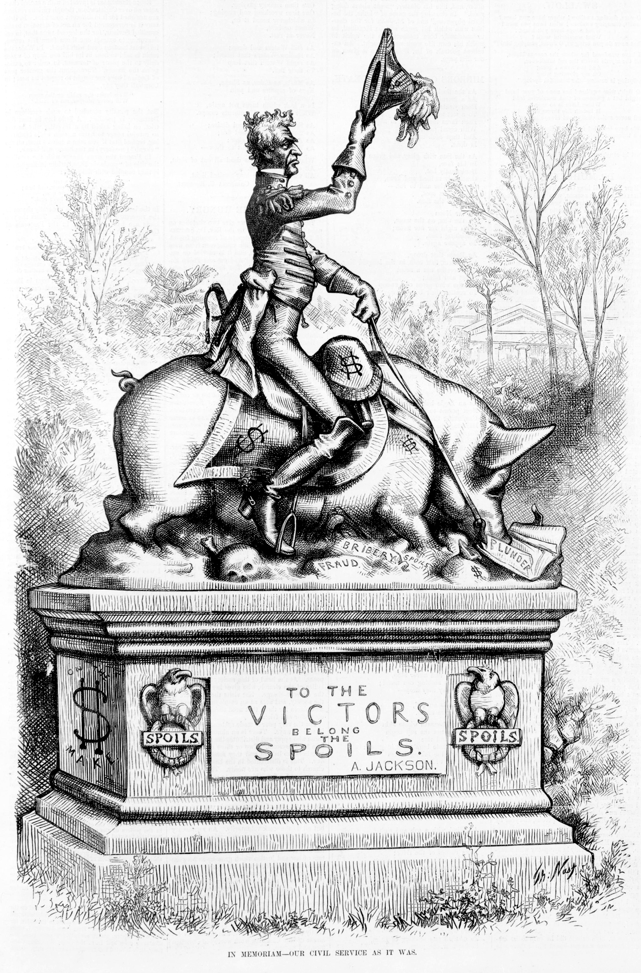
When Jackson began his term as President, he started replacing some government officials with his friends and supporters. Jackson claimed that putting new people into government jobs furthered democracy. However, instead of replacing these employees with other qualified employees, he replaced them with his own supporters. It was known as the Spoils System since it was a reward for his friends and his supporters. They were rewarded with a government position even though they did not do much to deserve their jobs.
Jackson rewarded many supporters with official Cabinet positions. Only Secretary of State Martin van Buren was truly qualified for his position. Since many of these official Cabinet members were unqualified, they rarely met. Instead of relying on his Cabinet members, Jackson relied on an unofficial group of friends for advice that became known as the “Kitchen Cabinet” (they often met in the White House kitchen).

- 7. Look at the Google Form responses from you and your classmates. After reading through the responses, choose one response from you/your classmates which best represents Andrew Jackson after reading the above passage. Re-type it below:
Answers will vary

- 8. Look at the Google Form responses. Did the majority (more) of Team Fire students feel this is a positive portrayal of Jackson, or negative?
Answers will vary.

- 9. Describe the Spoils System. (2-3 sentences).
When Jackson was elected, he started to replace government employees with his friends and supporters. Government positions went to supporters and friends as a reward for their support, even though they didn’t deserve the job or were unqualified.

- 10. Do you think it was a good idea for Jackson to put his friends and supporters in positions of power in the federal government? Why or why not?
Answers will vary.

