Name____________________________ Date__________
Period_________ Unit 7 Day 5

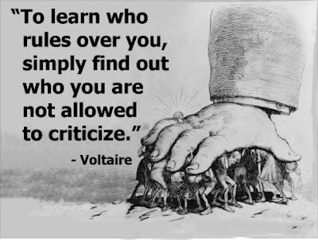
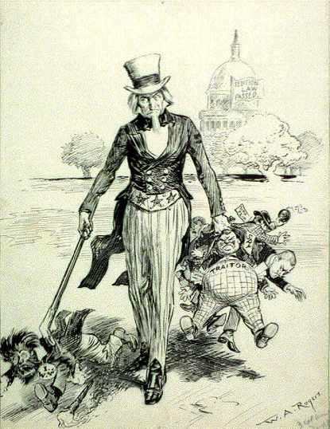
Documents 4 & 5: The Alien and Sedition Acts
- Who does the tall man in cartoon #1 represent?
Uncle Sam, the United States
- What are some of the words on the men he is holding?
Traitor, spy.

- Predict: Where is the tall man in the center taking the other men?
The tall man is taking the other man to jail for speaking out against the government.
- Which law is being depicted in cartoon #1? Explain this law by using your notes!
The Sedition Act. The Sedition Act made it a crime to say or write anything insulting or false about the government, the President, or Congress.
- Why was this law passed? Because the Democratic-Republicans and some Federalists were criticizing Adams’ response to the XYZ Affair.
- Explain how the quote in cartoon #2 is related to the events/law depicted in cartoon #1.
Cartoon #2 shows a hand trying to crush a group of people. The quote says that in order to find out who is in charge, criticize them, and they will punish you. The Sedition Act made it a crime to speak out against the government. If you spoke badly about the government, you could be silenced by being put in jail or fined.

